ATMA RAM SANATAN DHARMA COLLEGE

UNIVERSITY 0F DELHI



NAME – NISHANT MURMU

COURSE – BSC HONS. COMPUTER SCIENCE

ROLL NO- 23/38023

SUBJECT- COMPUTER SYSTEM ARCHITECTURE

PRACTICAL FILE

SUBMITTED TO-

DR. UMA OJHA

**PRACTICAL-1**

**Objective**

**Create a machine based on the given architecture and design the register set, memory and instruction format for the machine.**

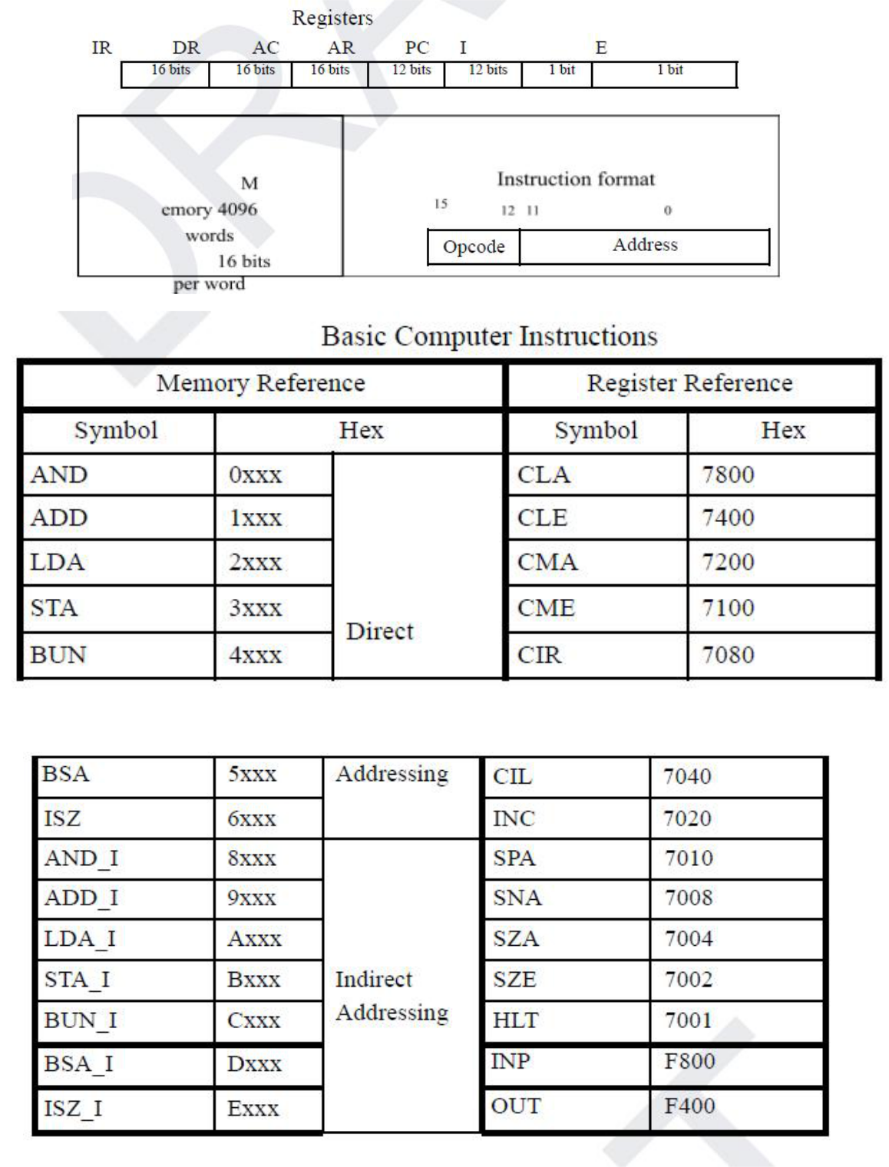

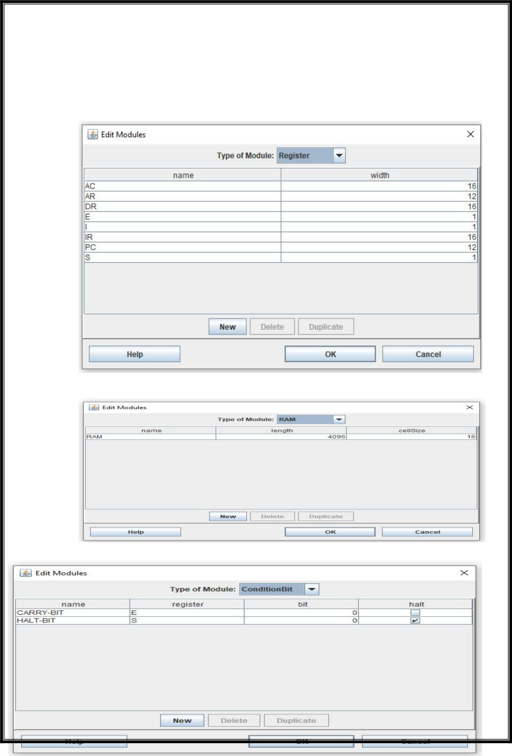

**Observation**

**Registers**

**Memory**

**Condition Bits**

**PRACTICAL-**2

**Objective**

**Create a Fetch Routine of the Instruction Cycle.**

**Observation**

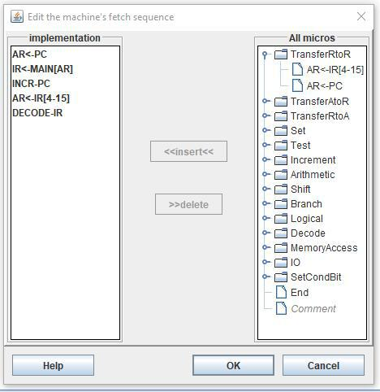

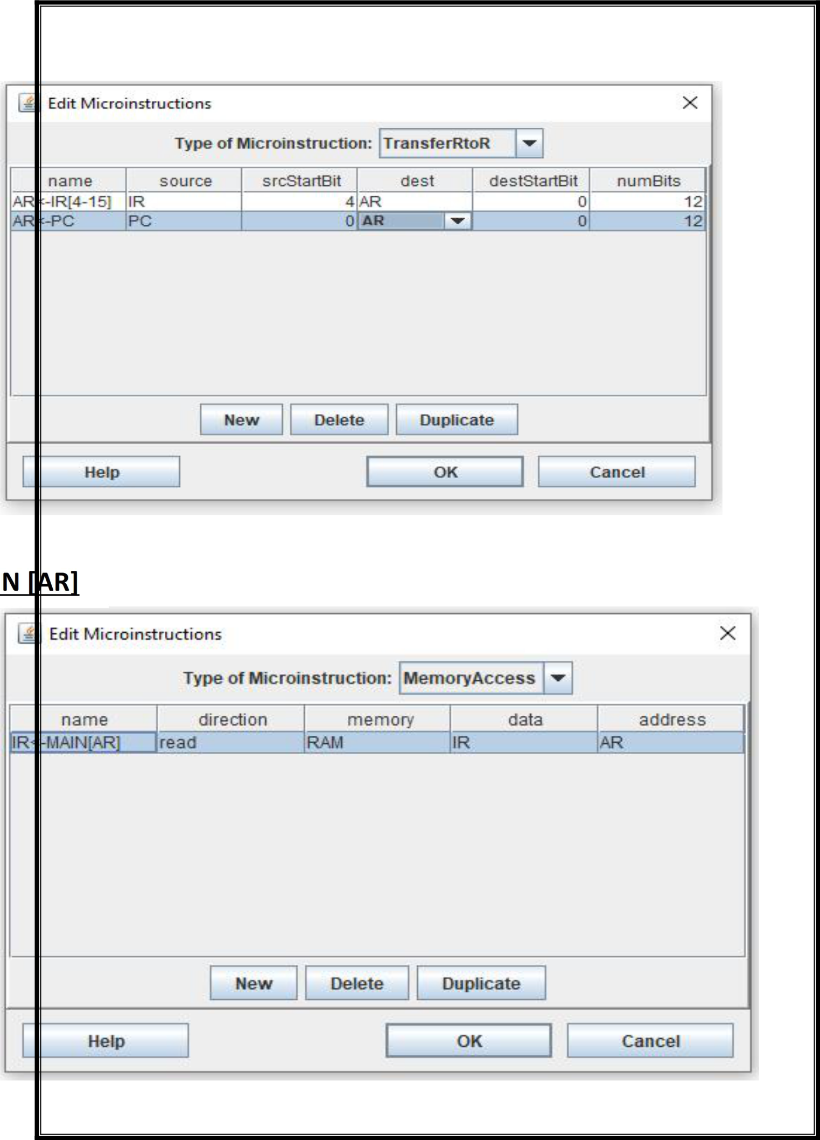**PC<- AR**

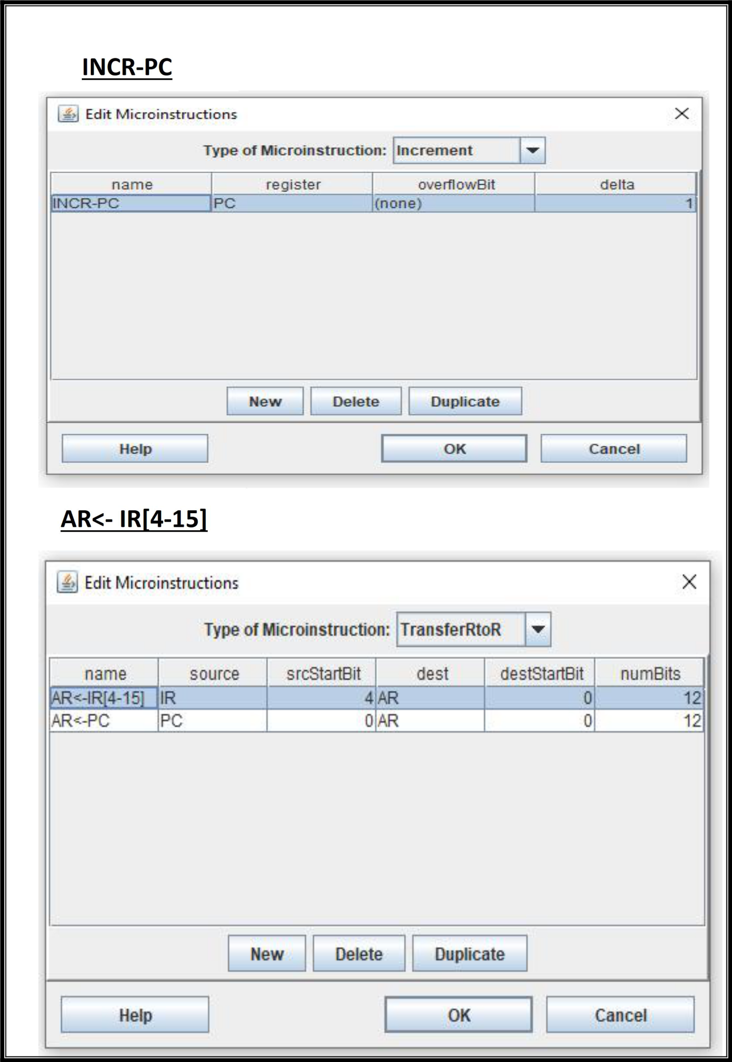

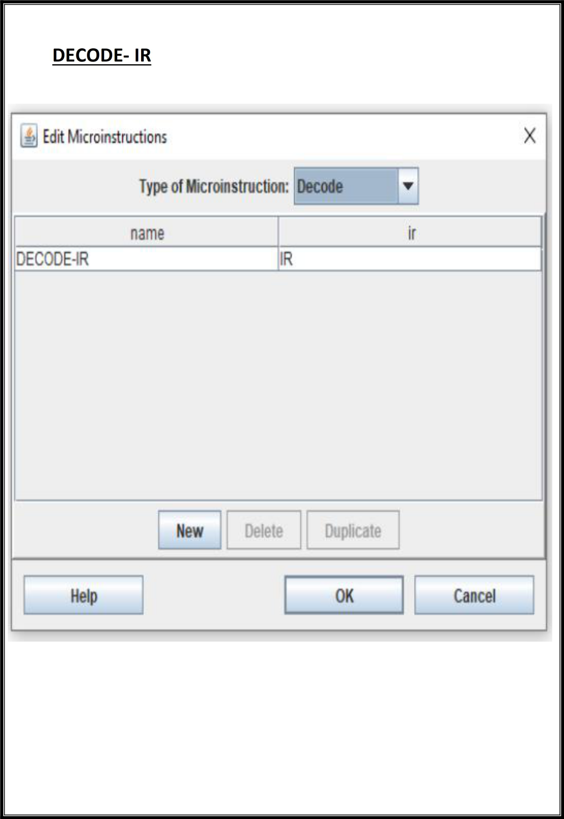

**PRACTICAL-**3

**Objective**

**Write and assembly program to simulate ADD operation on two user entered numbers.**

**Observation**

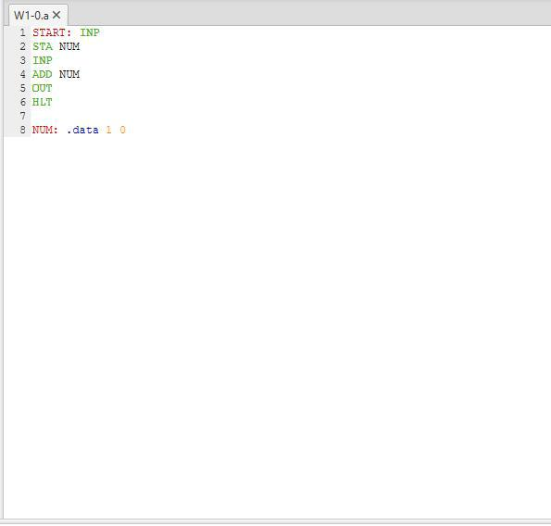

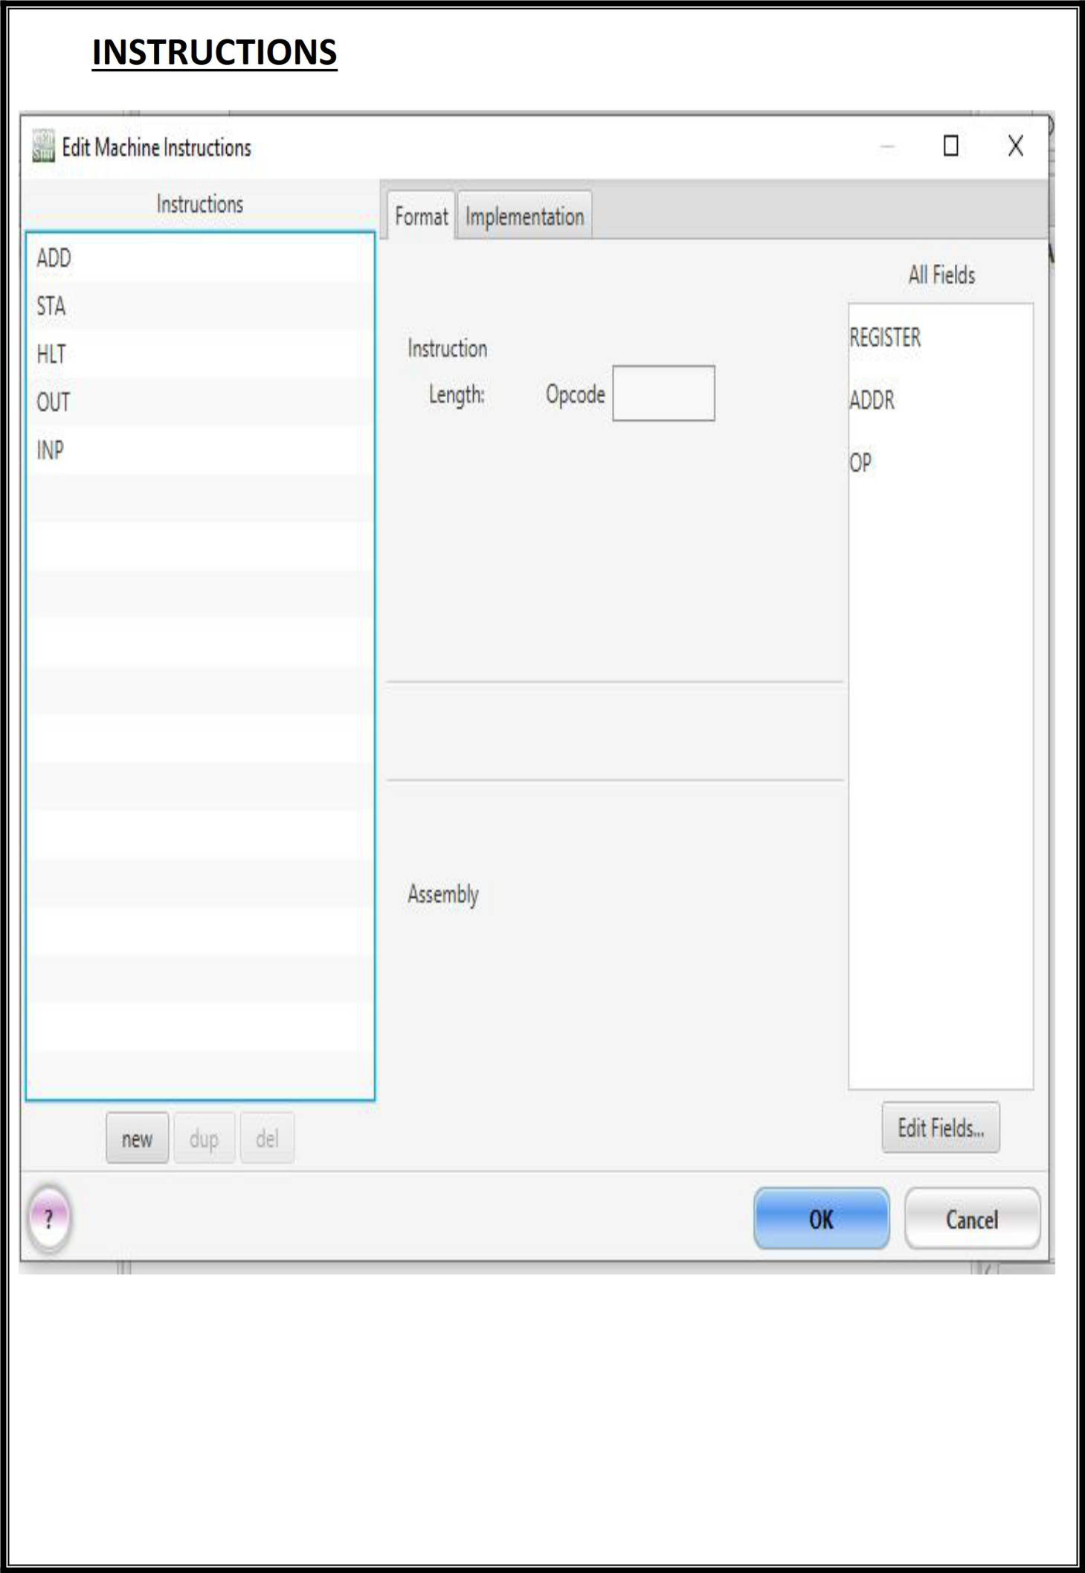

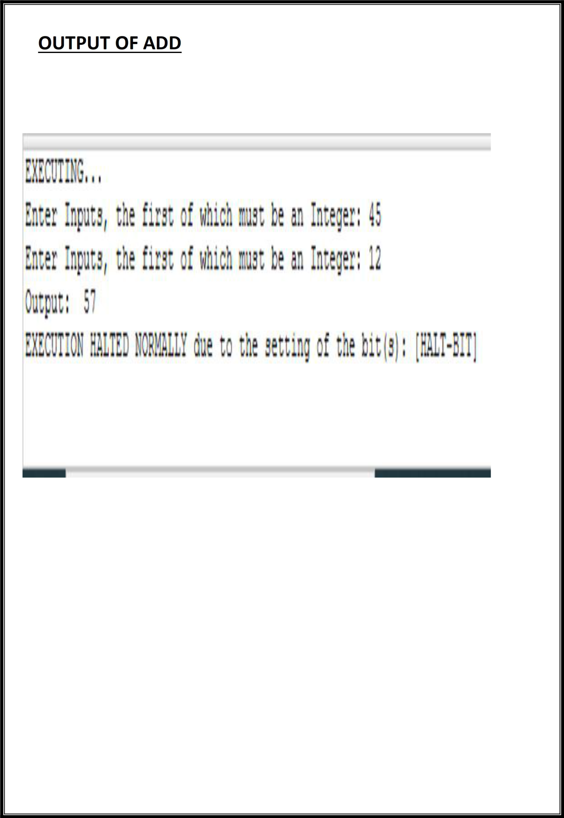

**PRACTICAL-**4

**Objective**

Write and assembly program to simulate **SUBTRACT** operation on two user entered numbers.

**Observation**

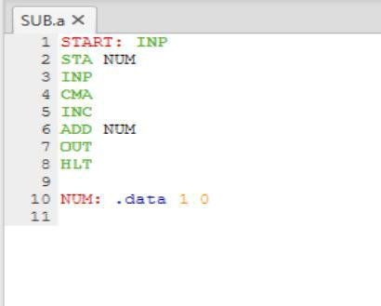

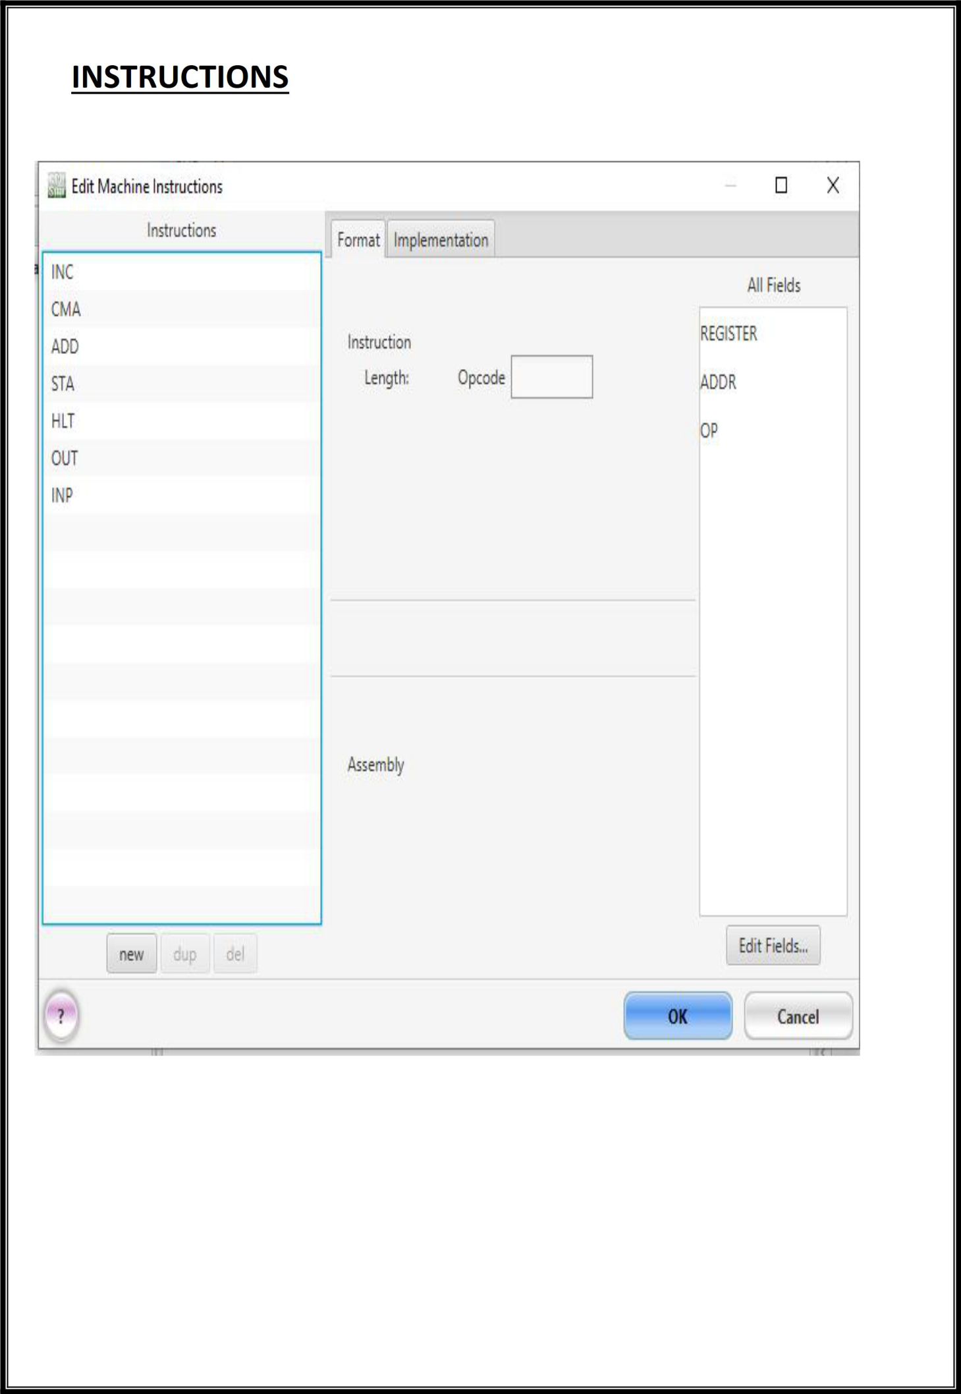

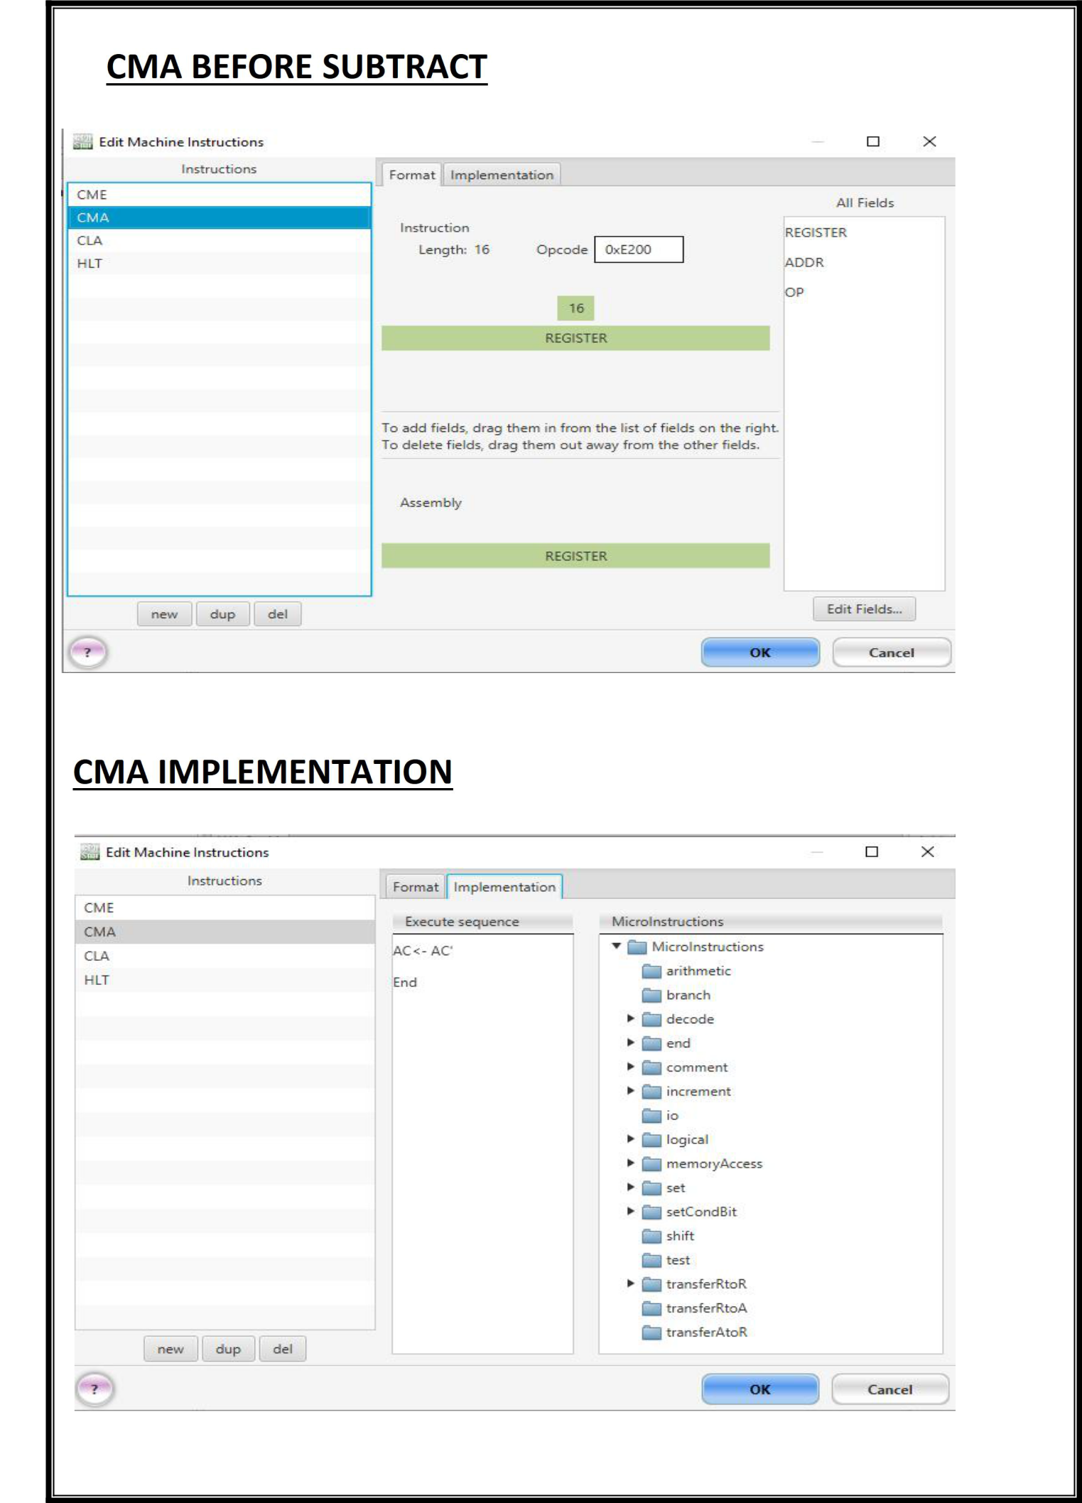

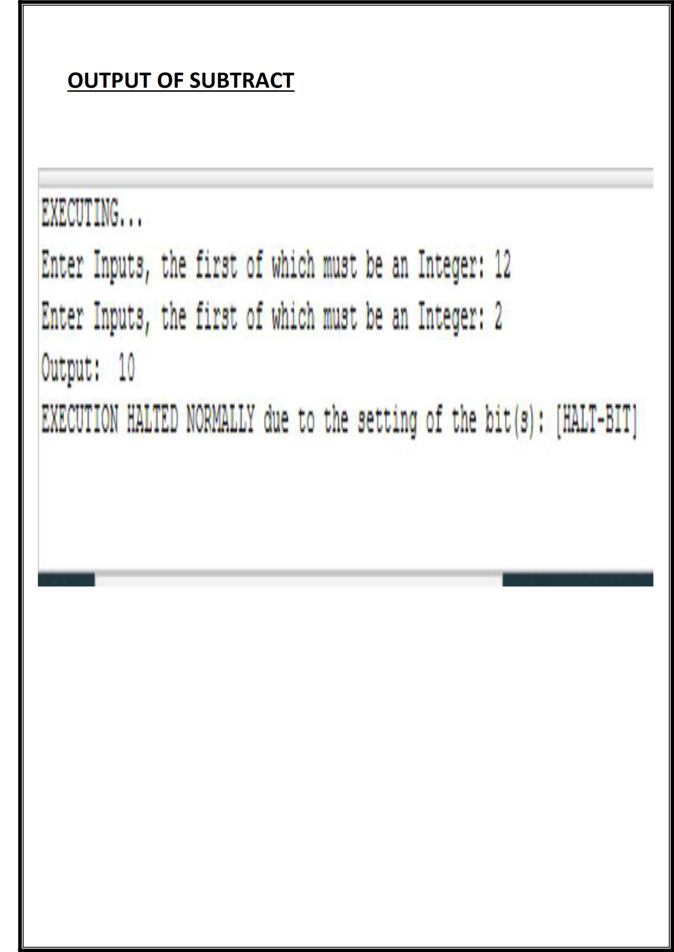

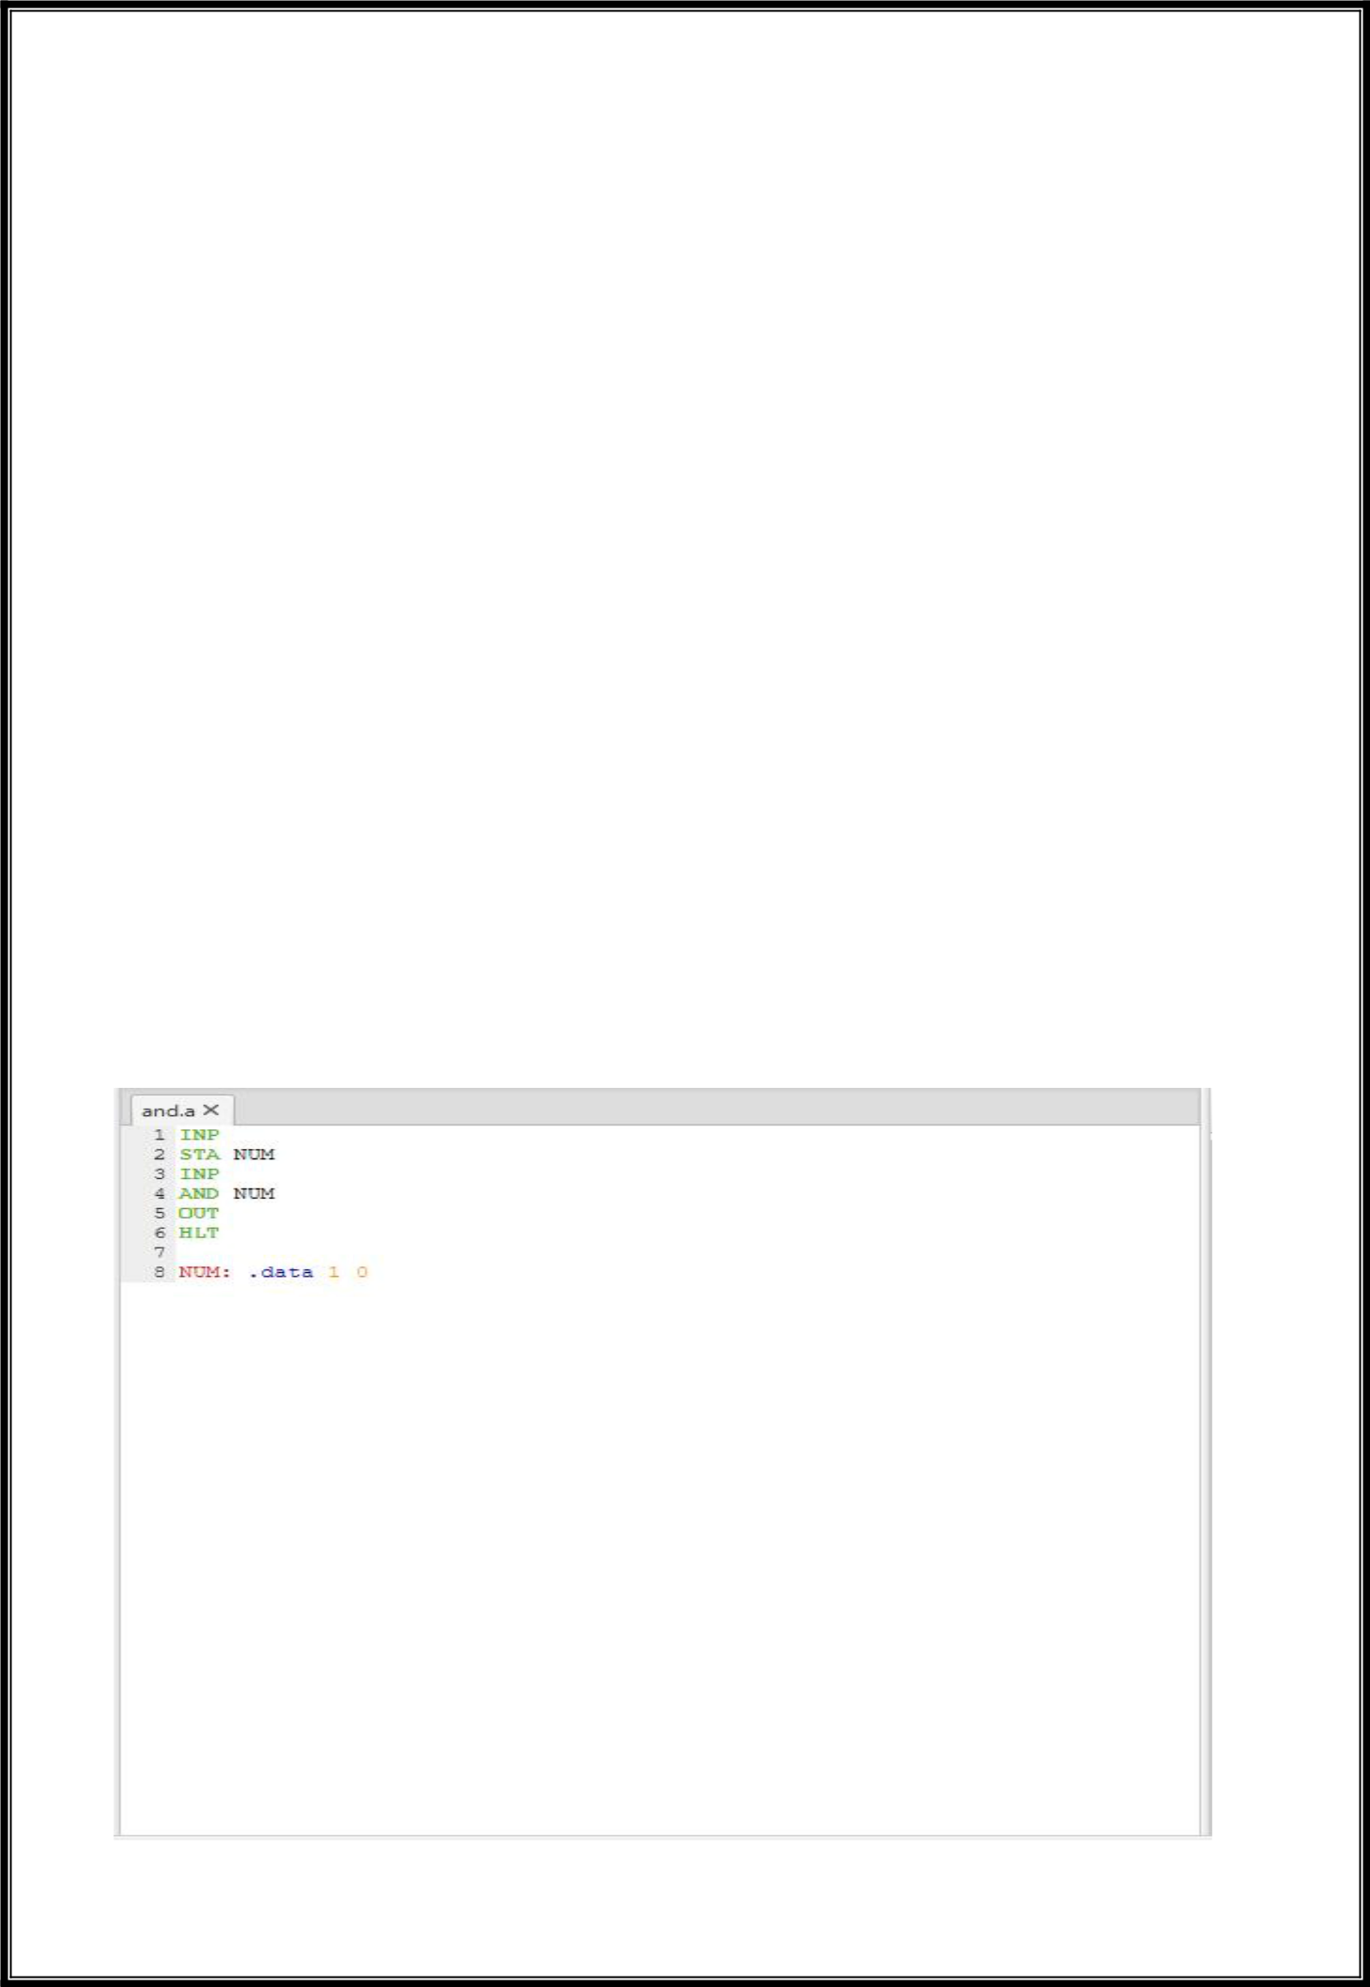**PRACTICAL 5**

**Objective**

Write an assembly program to simulate the following logical operations on two user entered numbers.

1. **AND**
2. **OR**
3. **NOT**
4. **XOR**
5. **NOR**
6. **NAND**

**Observation**

**i. AND**

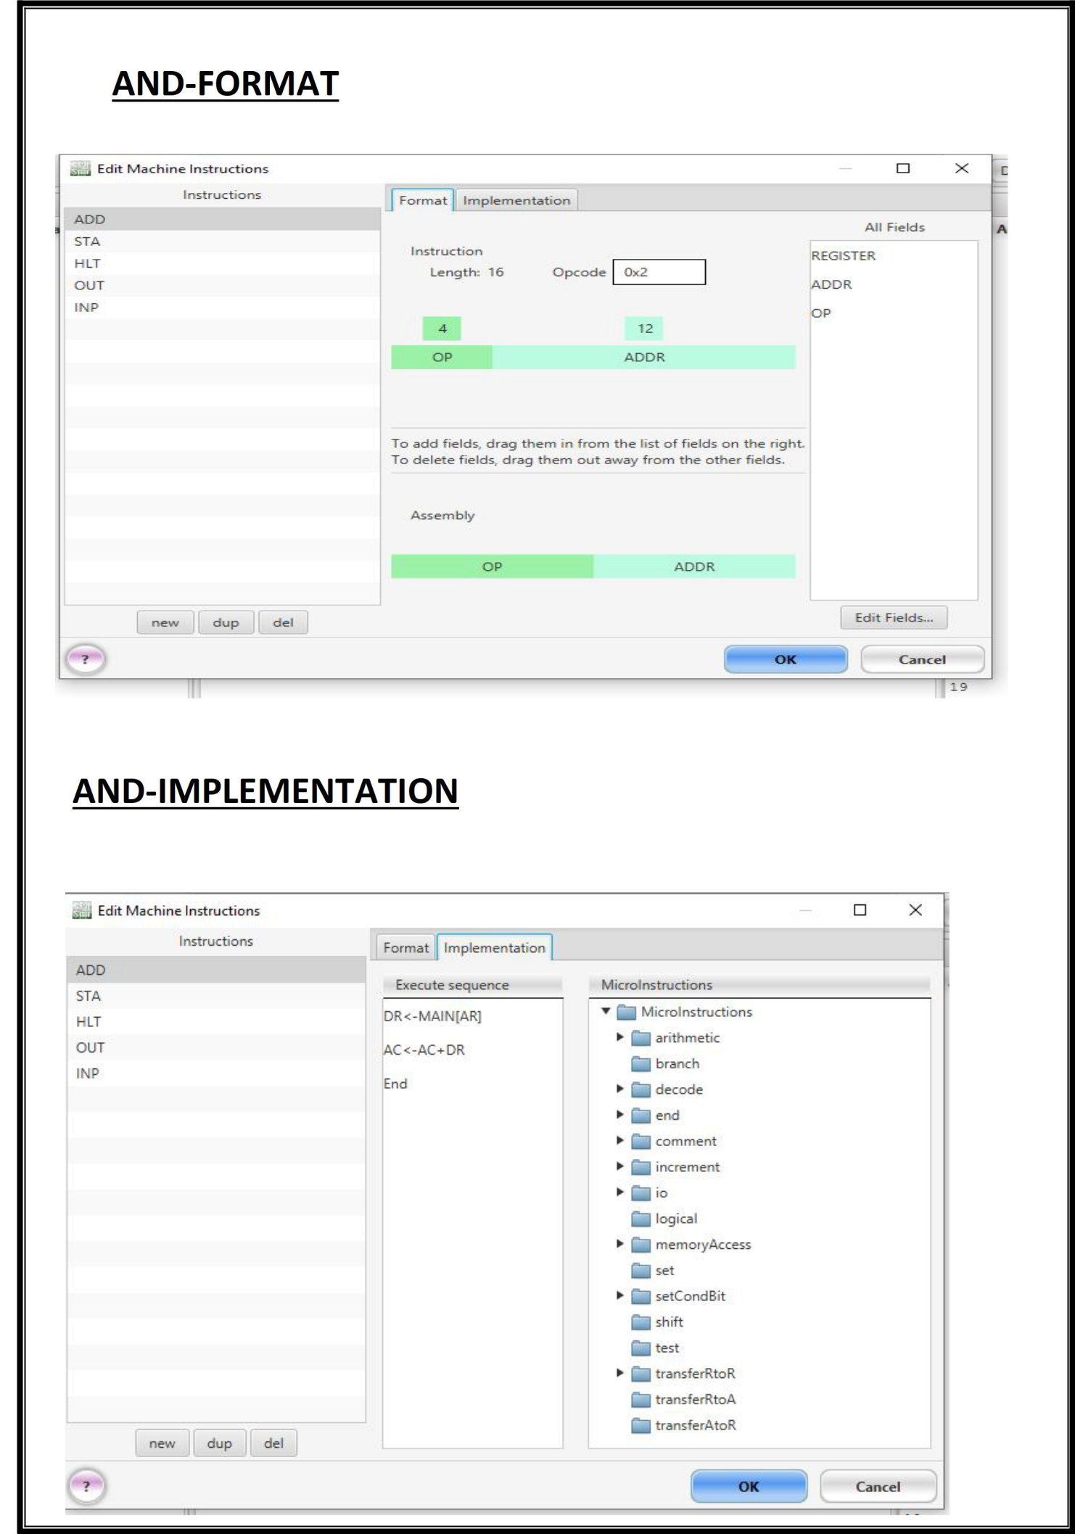

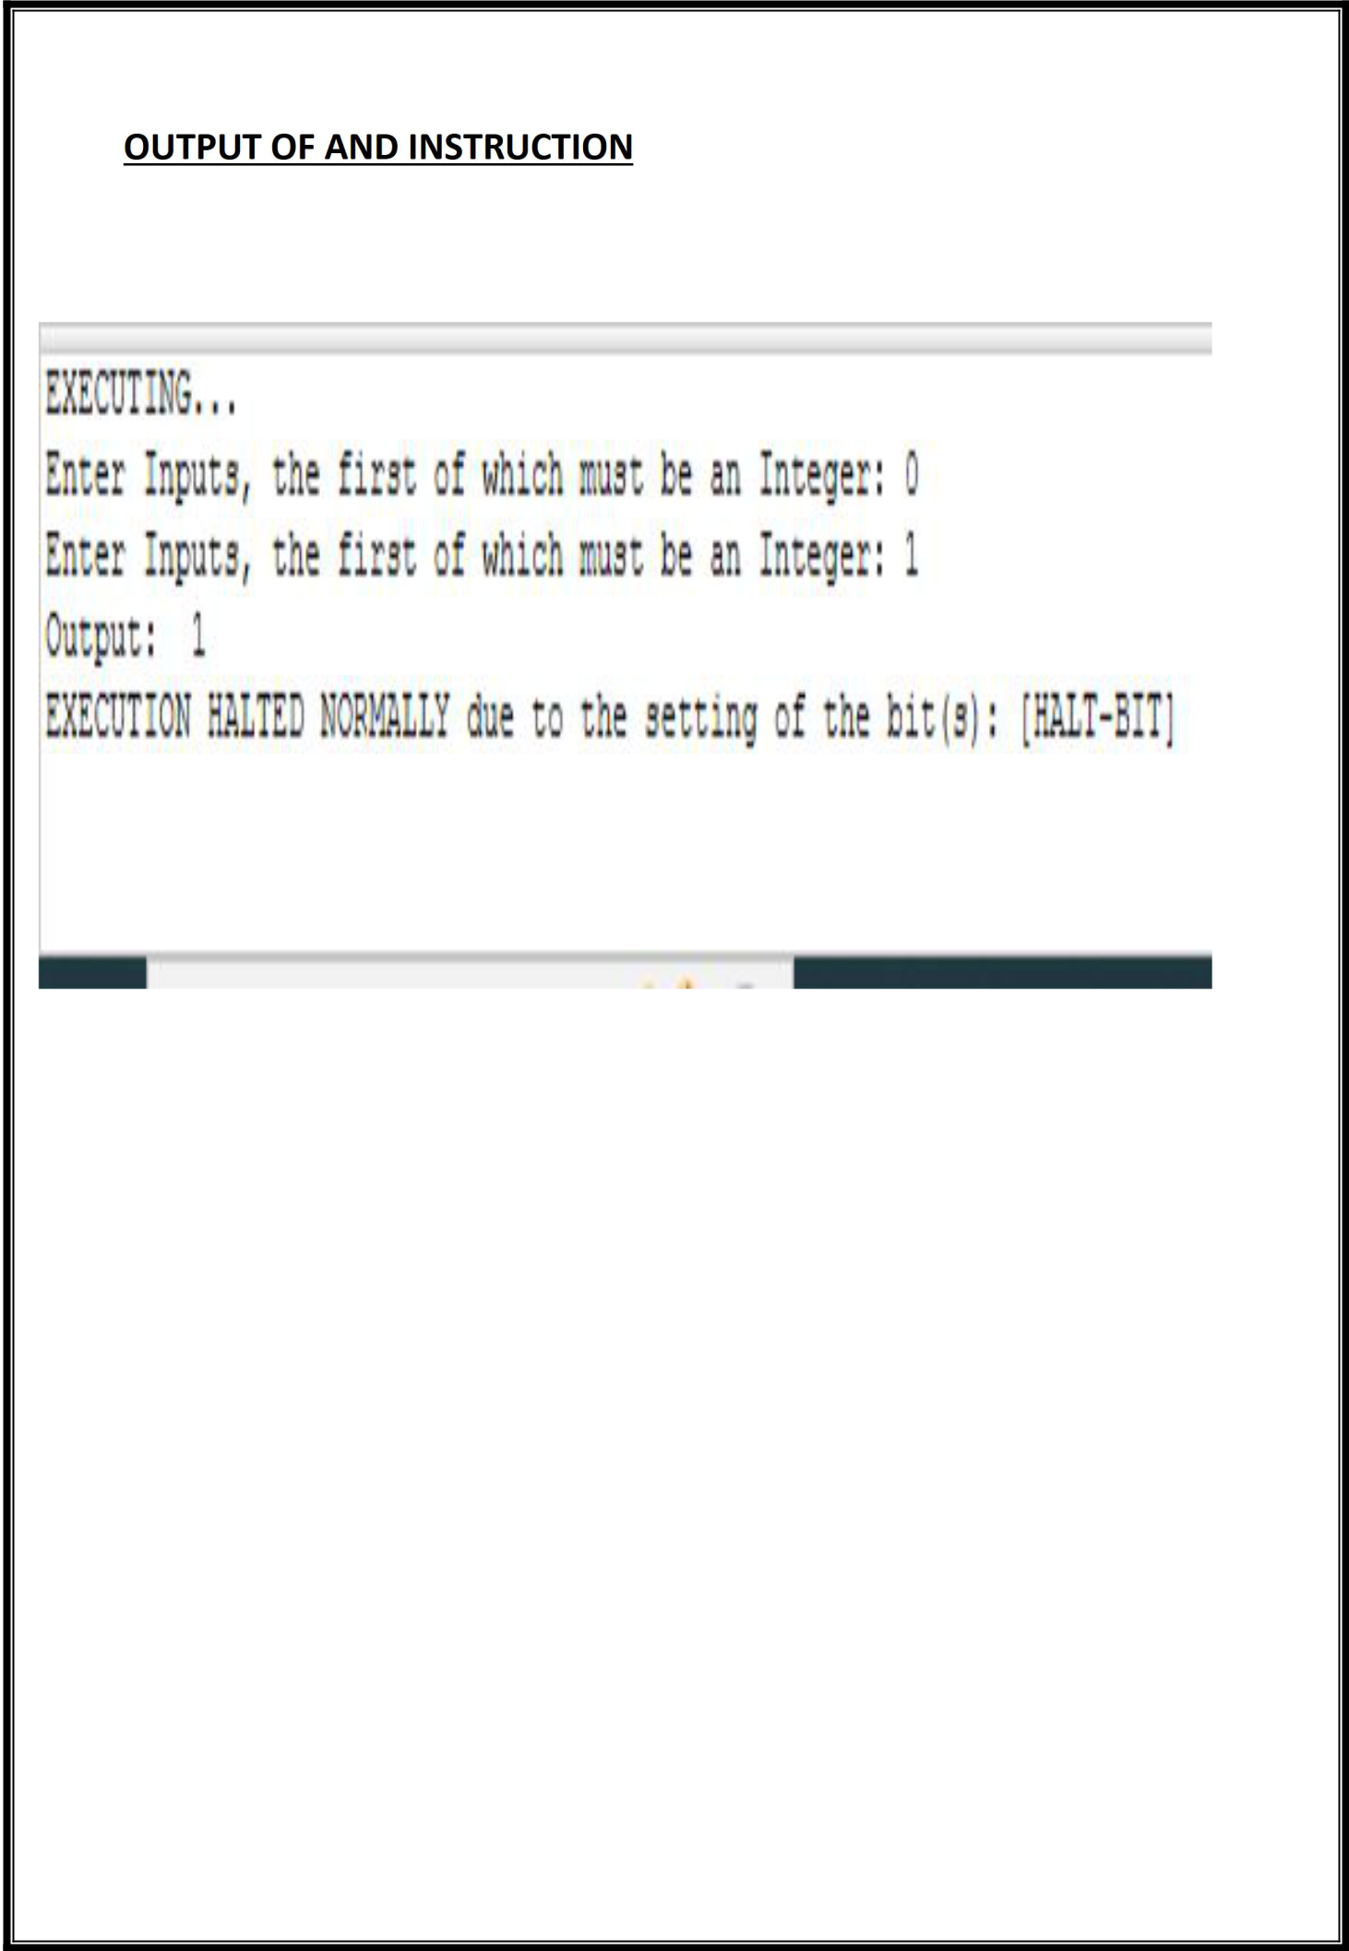

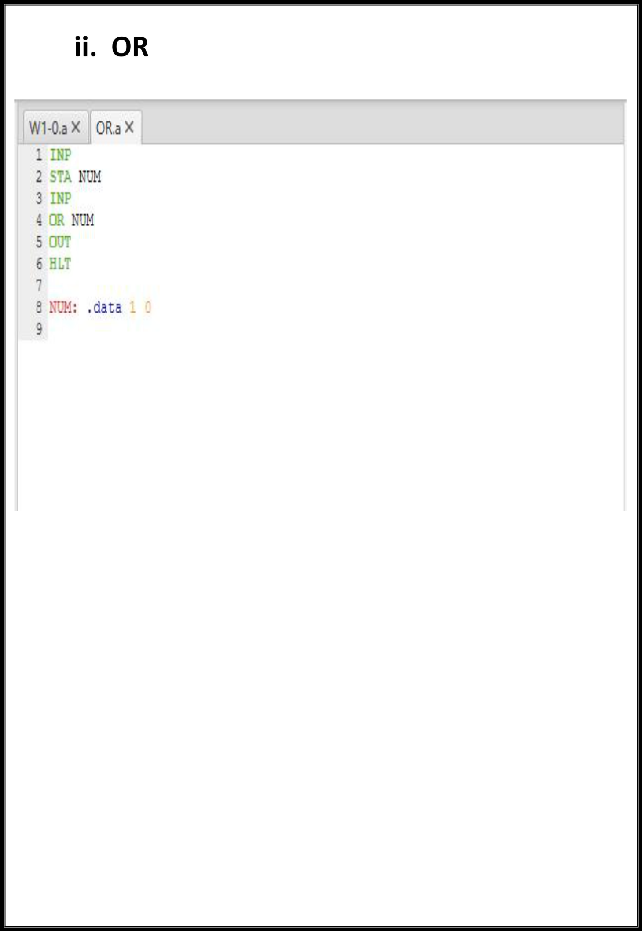

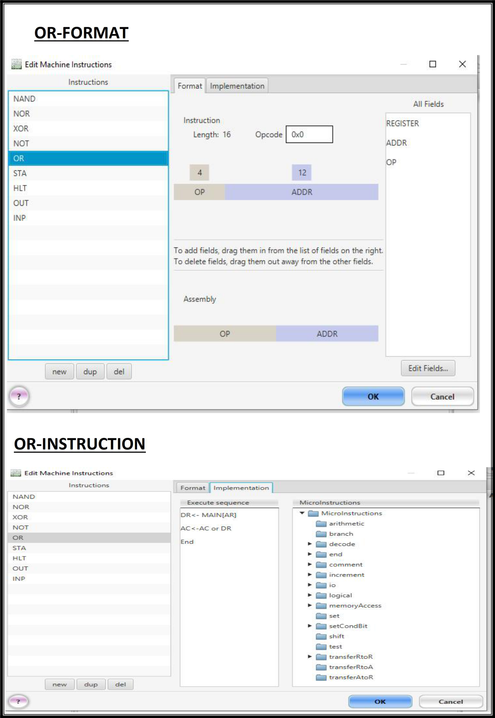

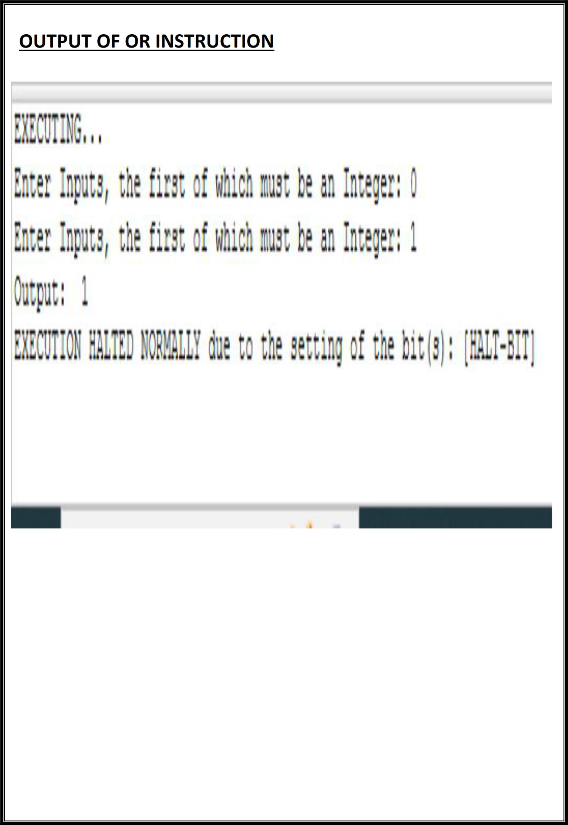

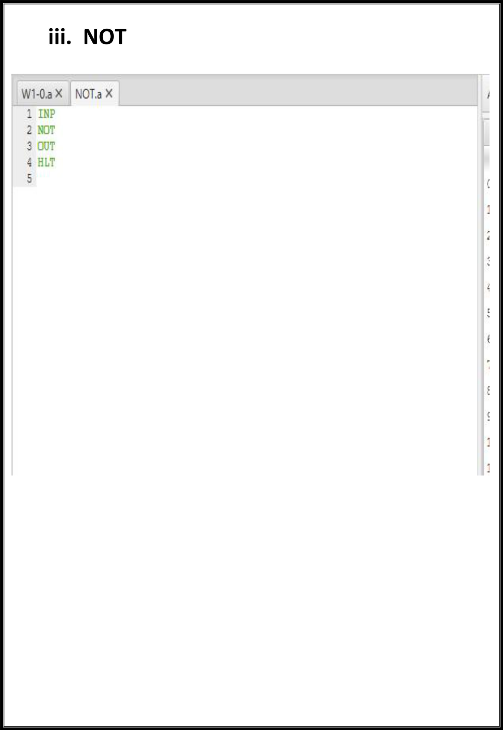

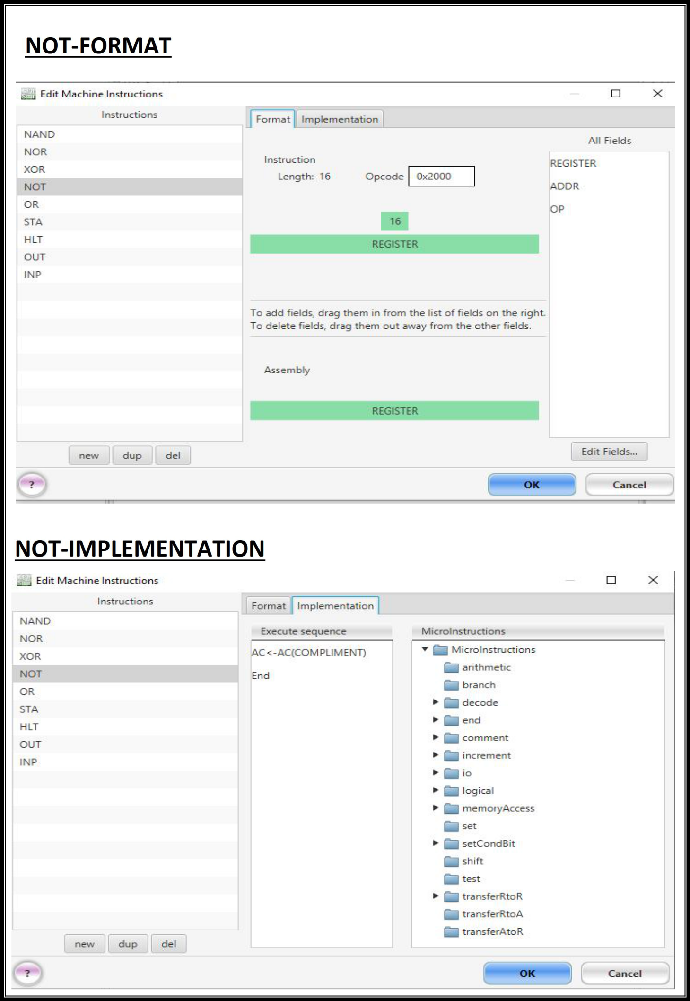

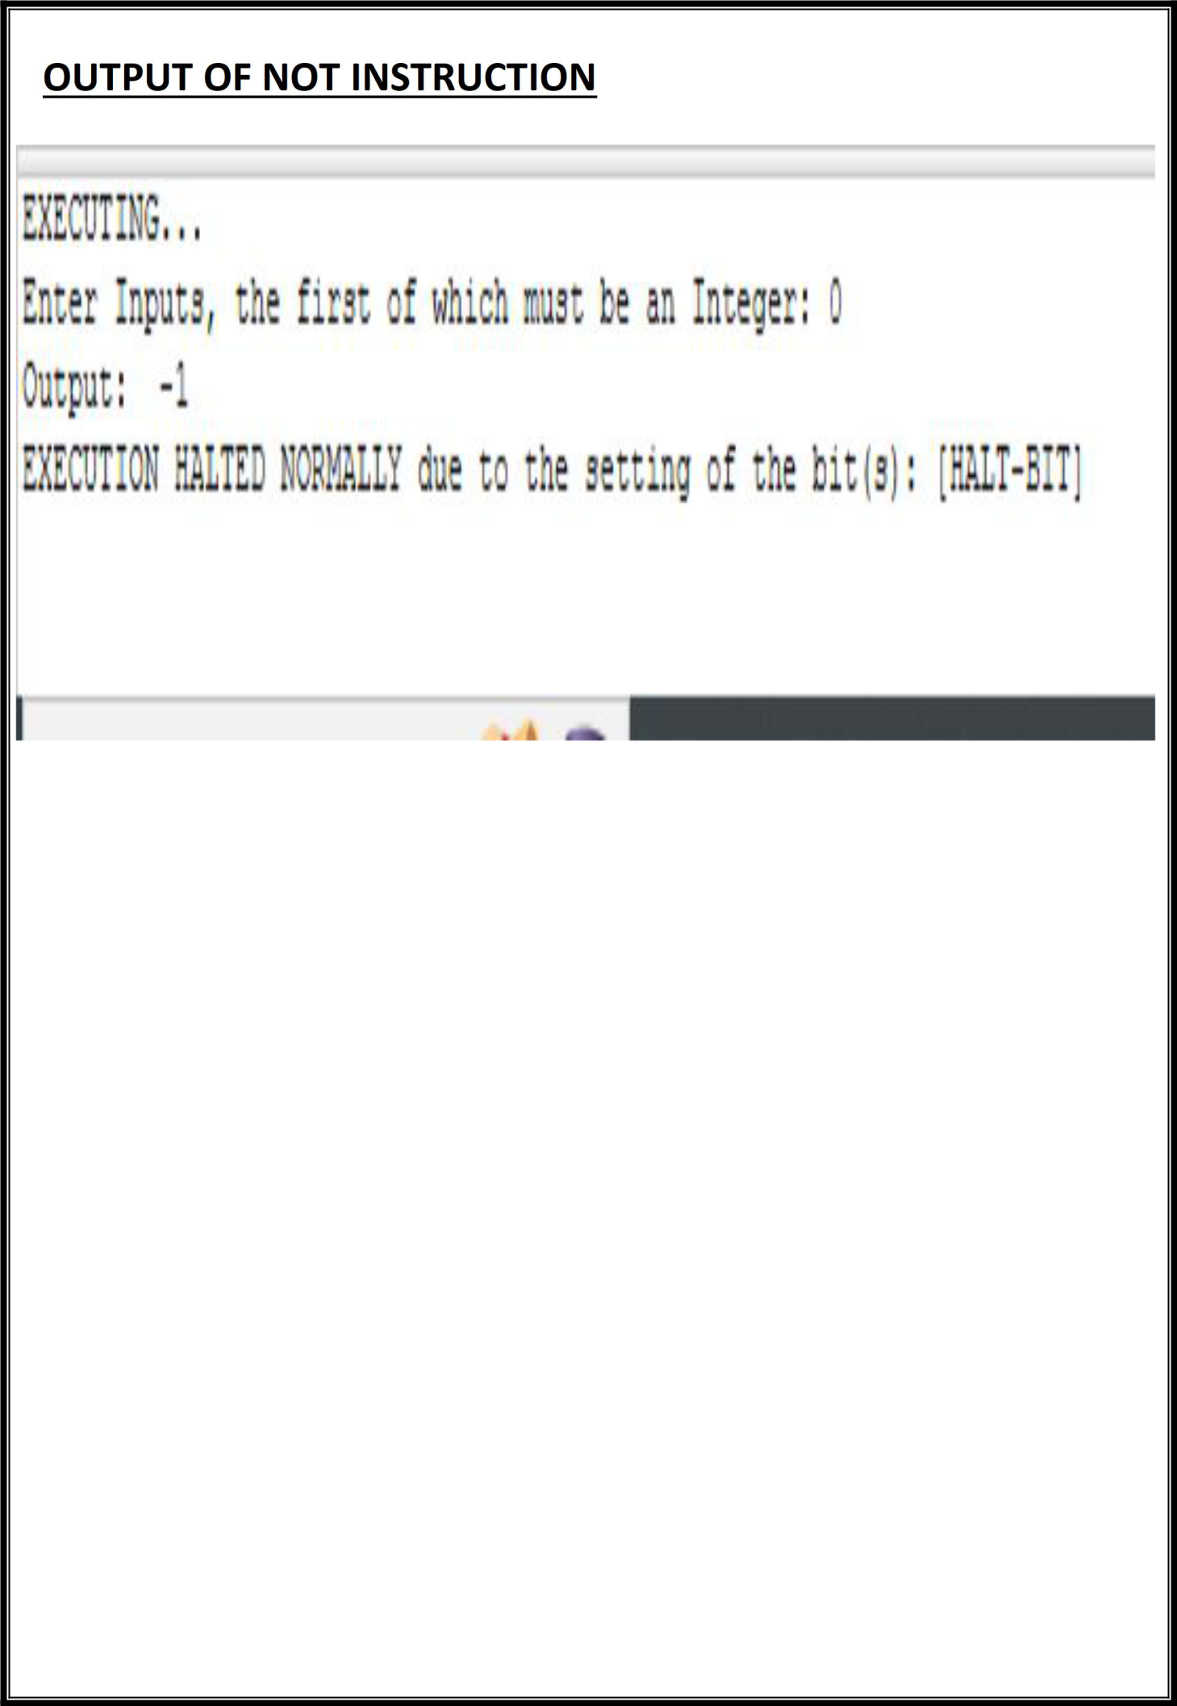

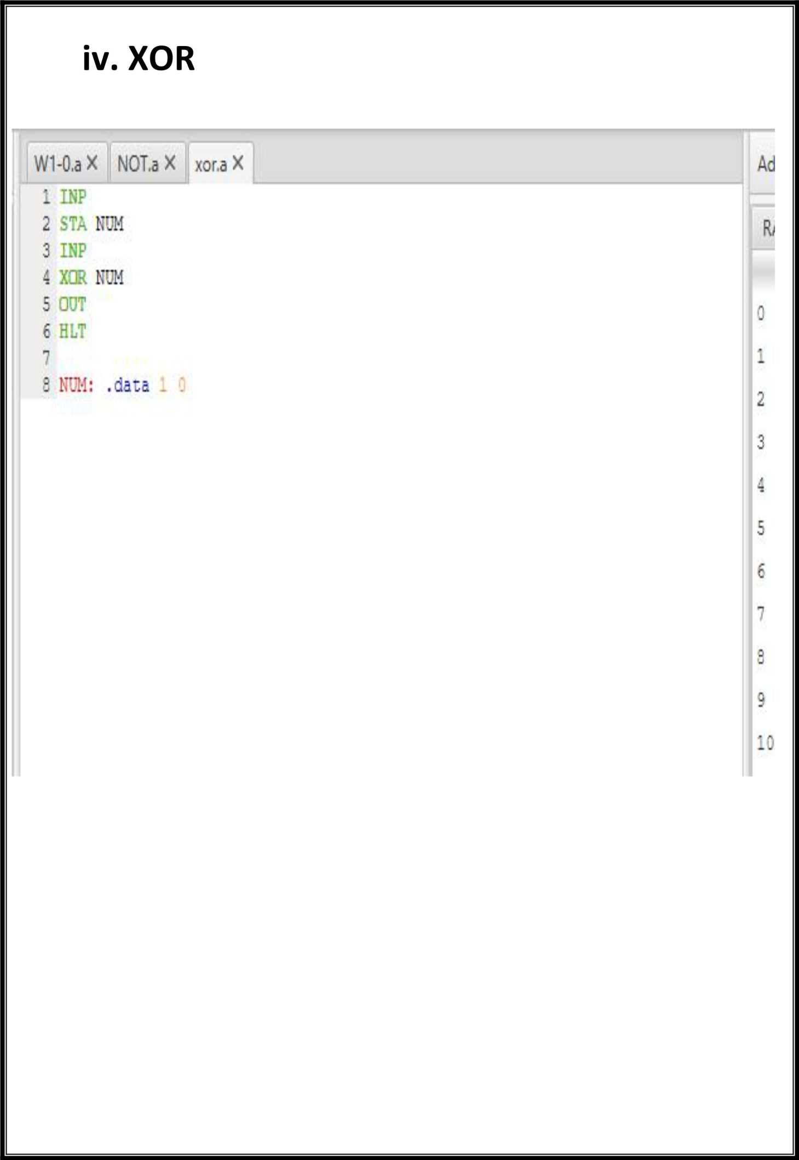

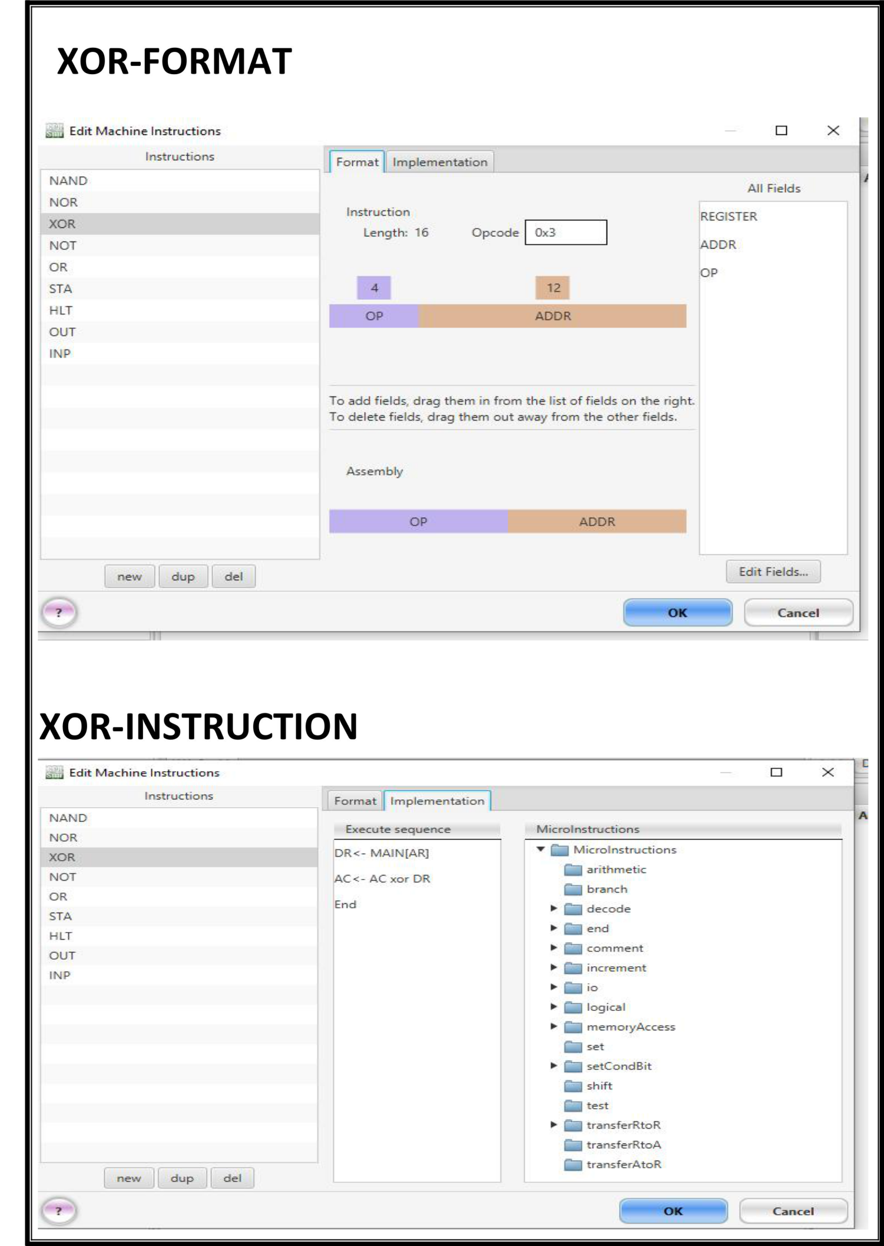

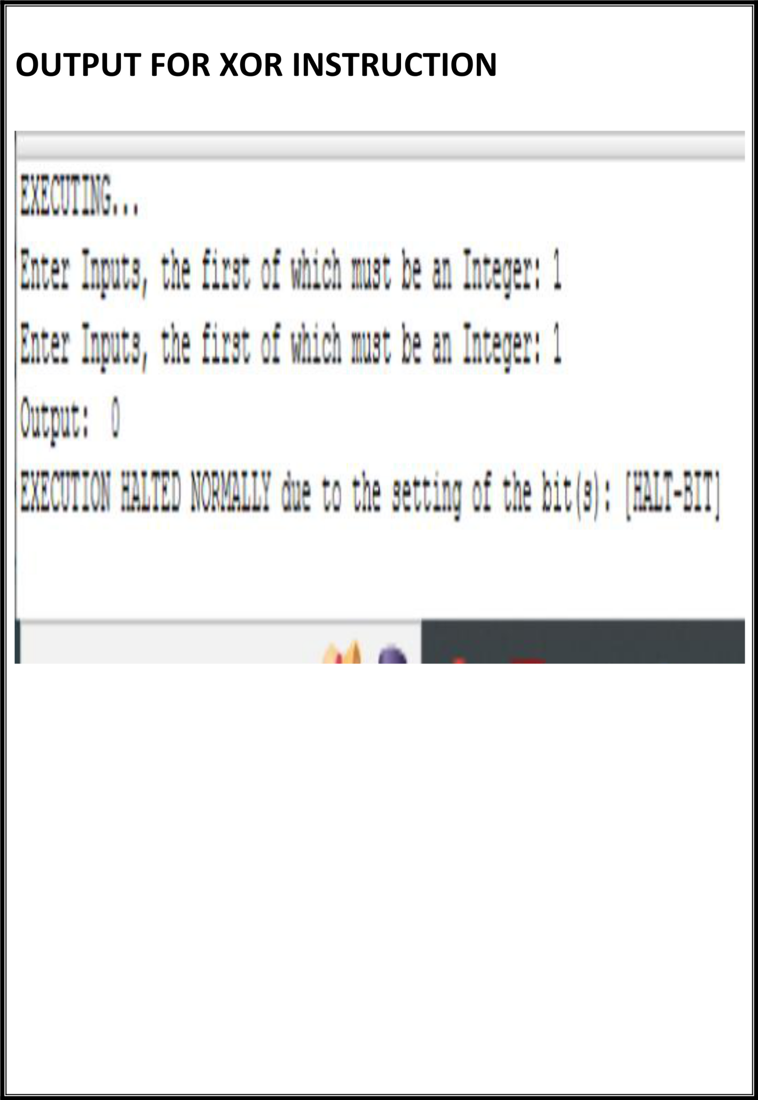

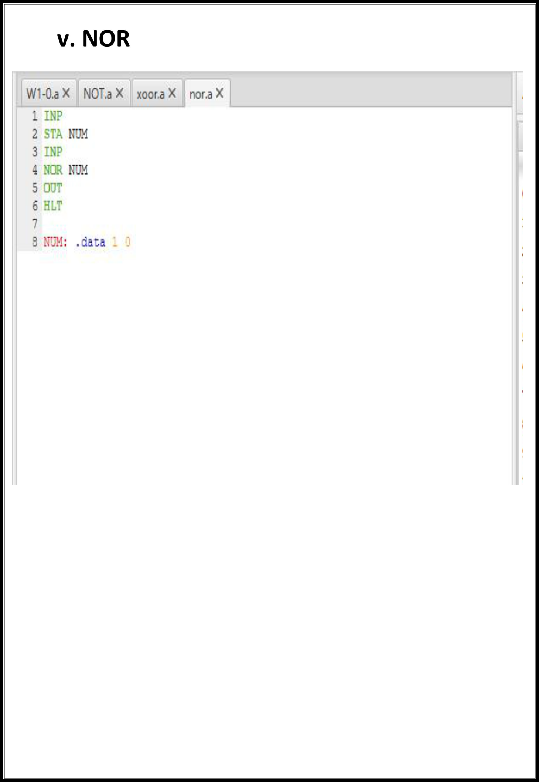

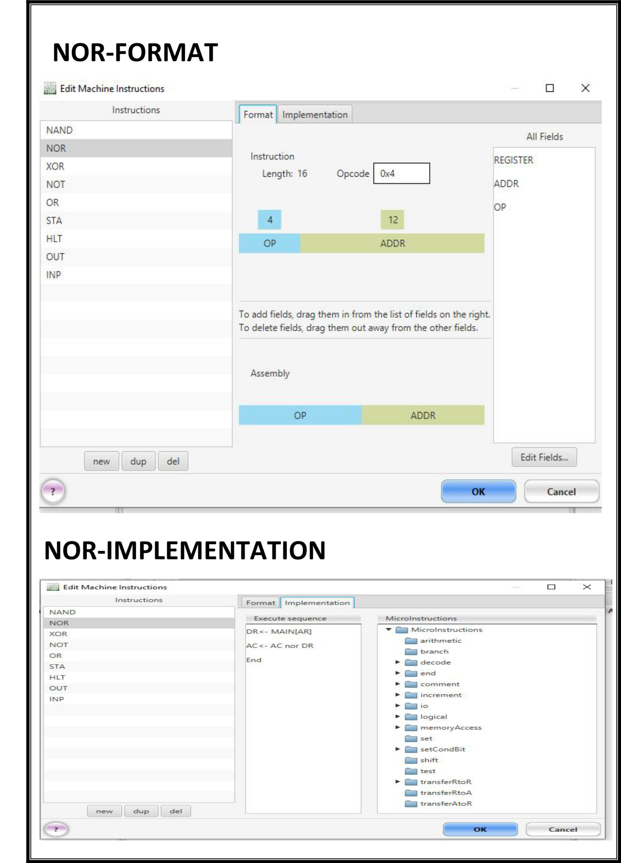

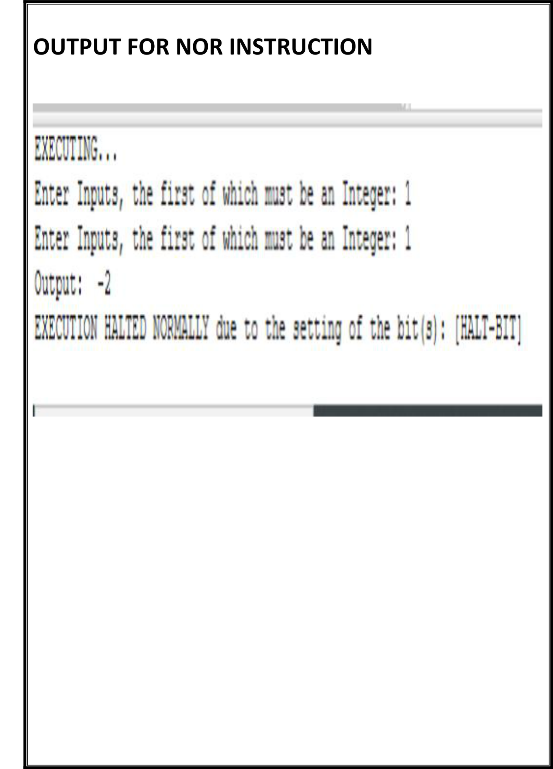

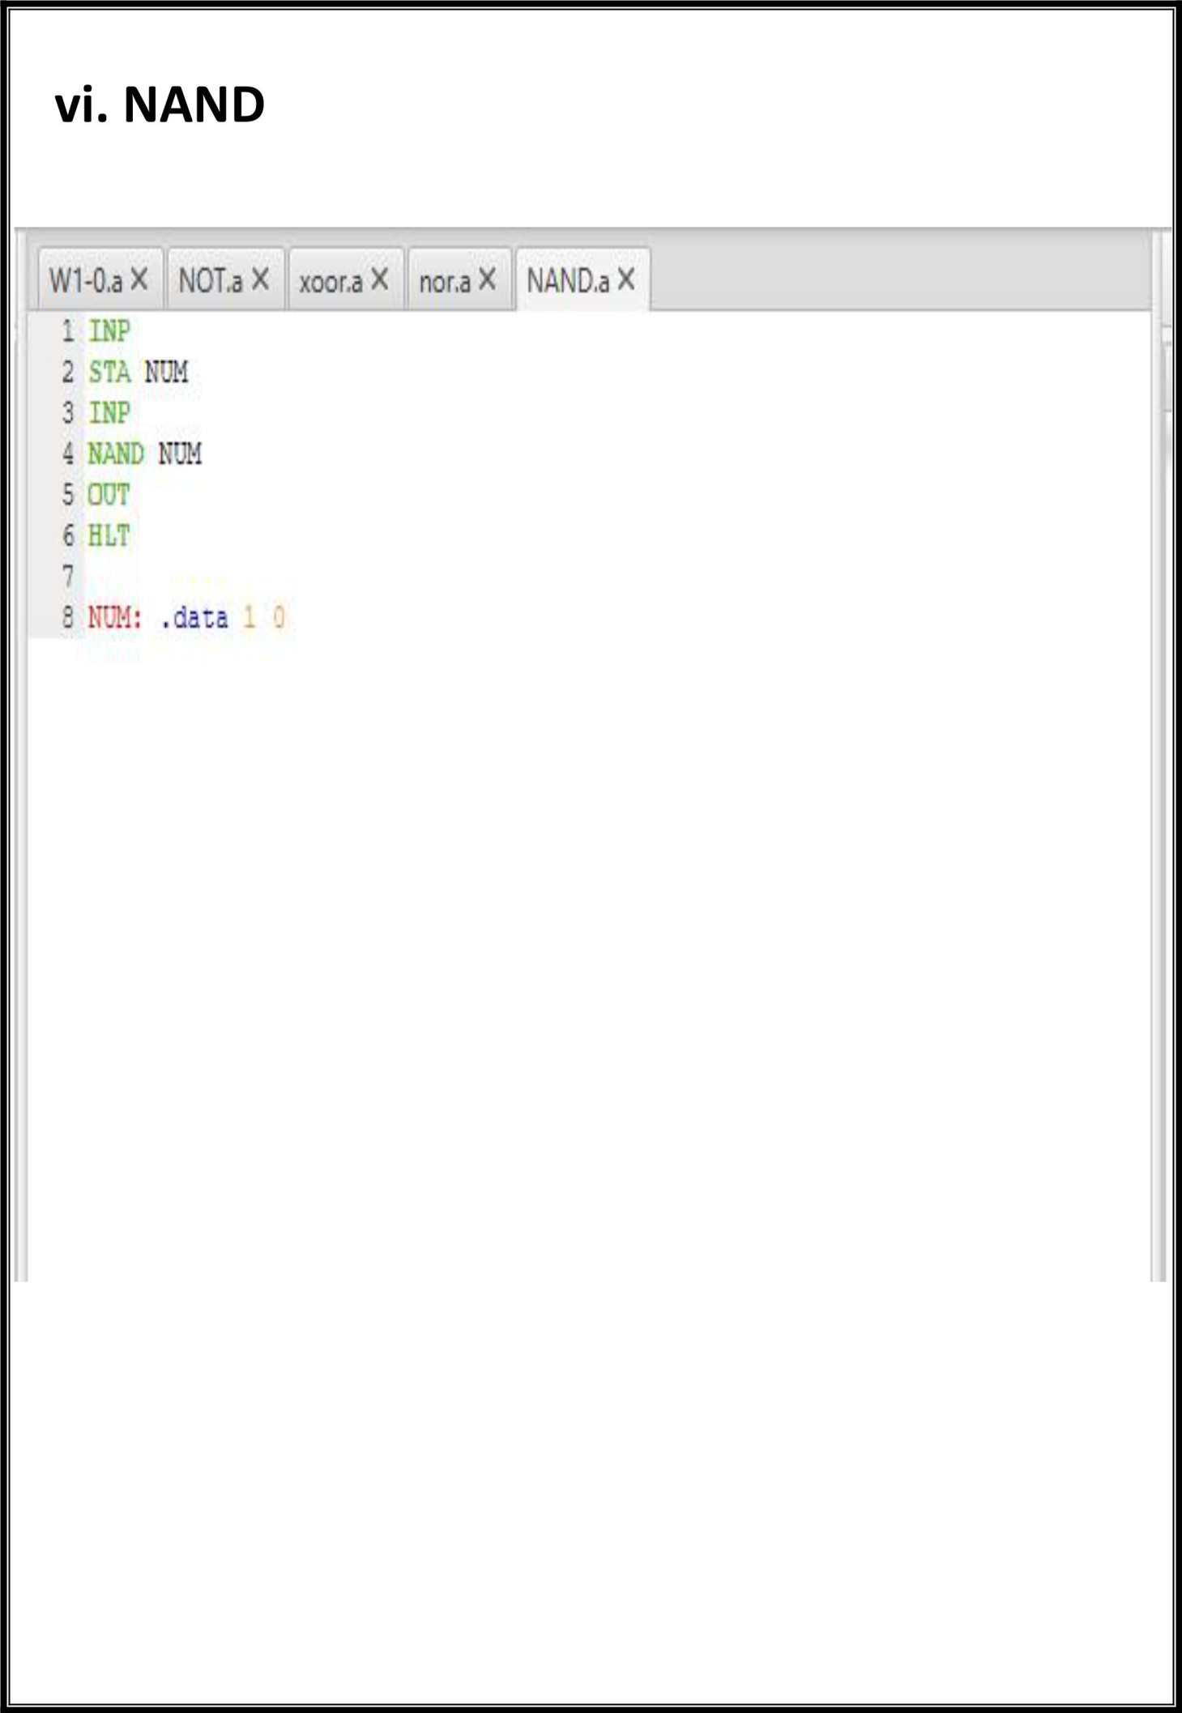

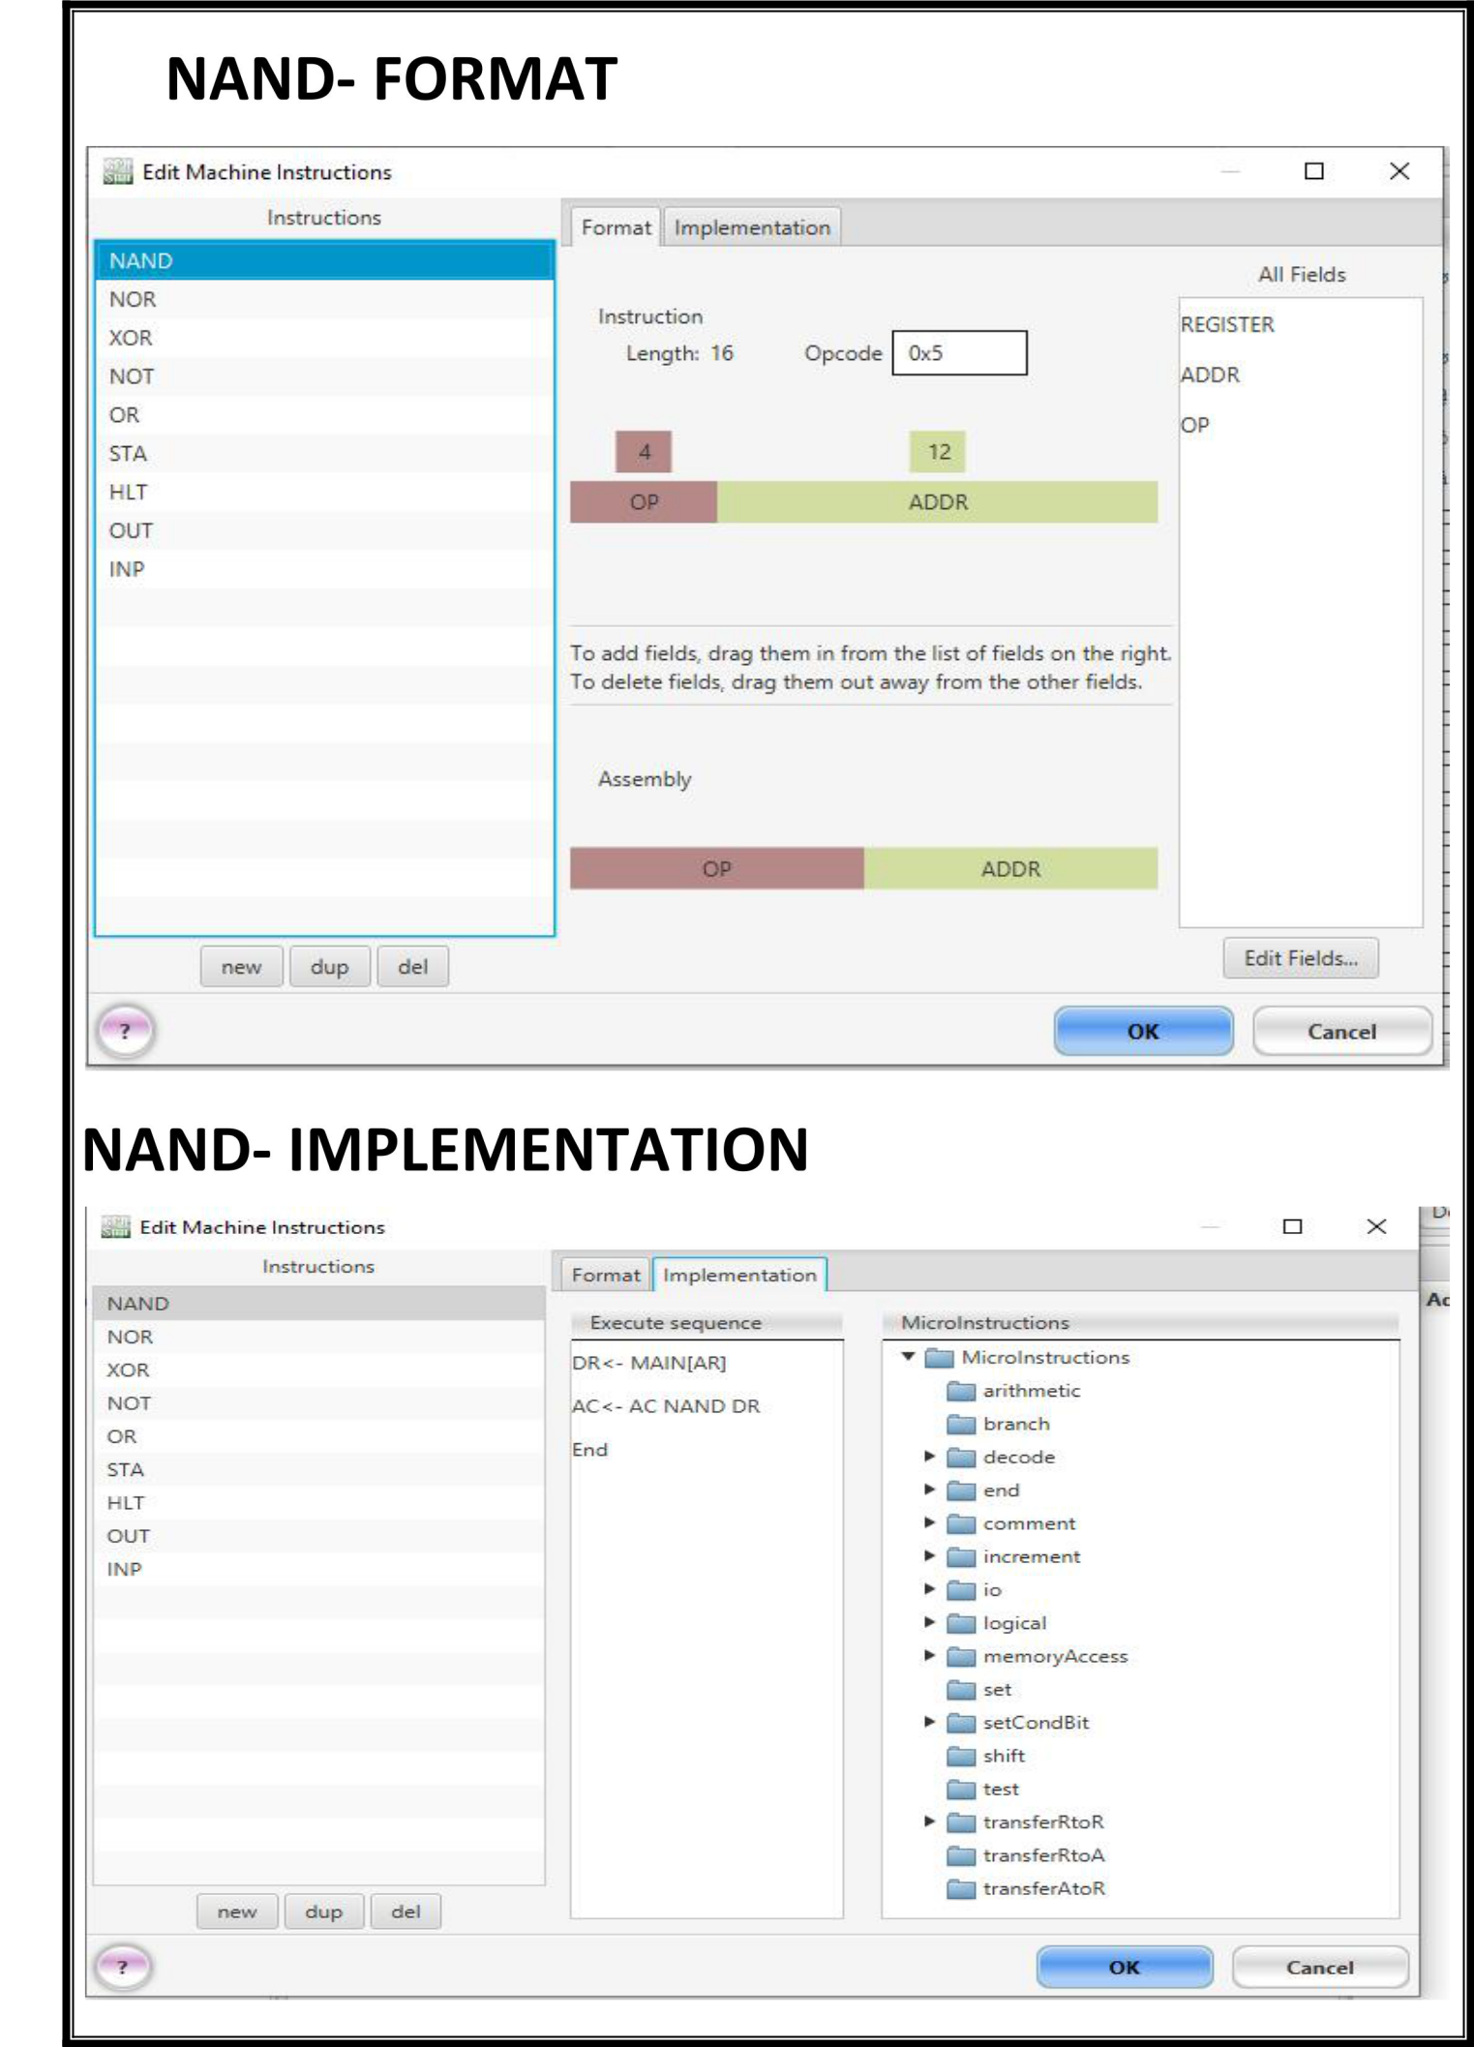

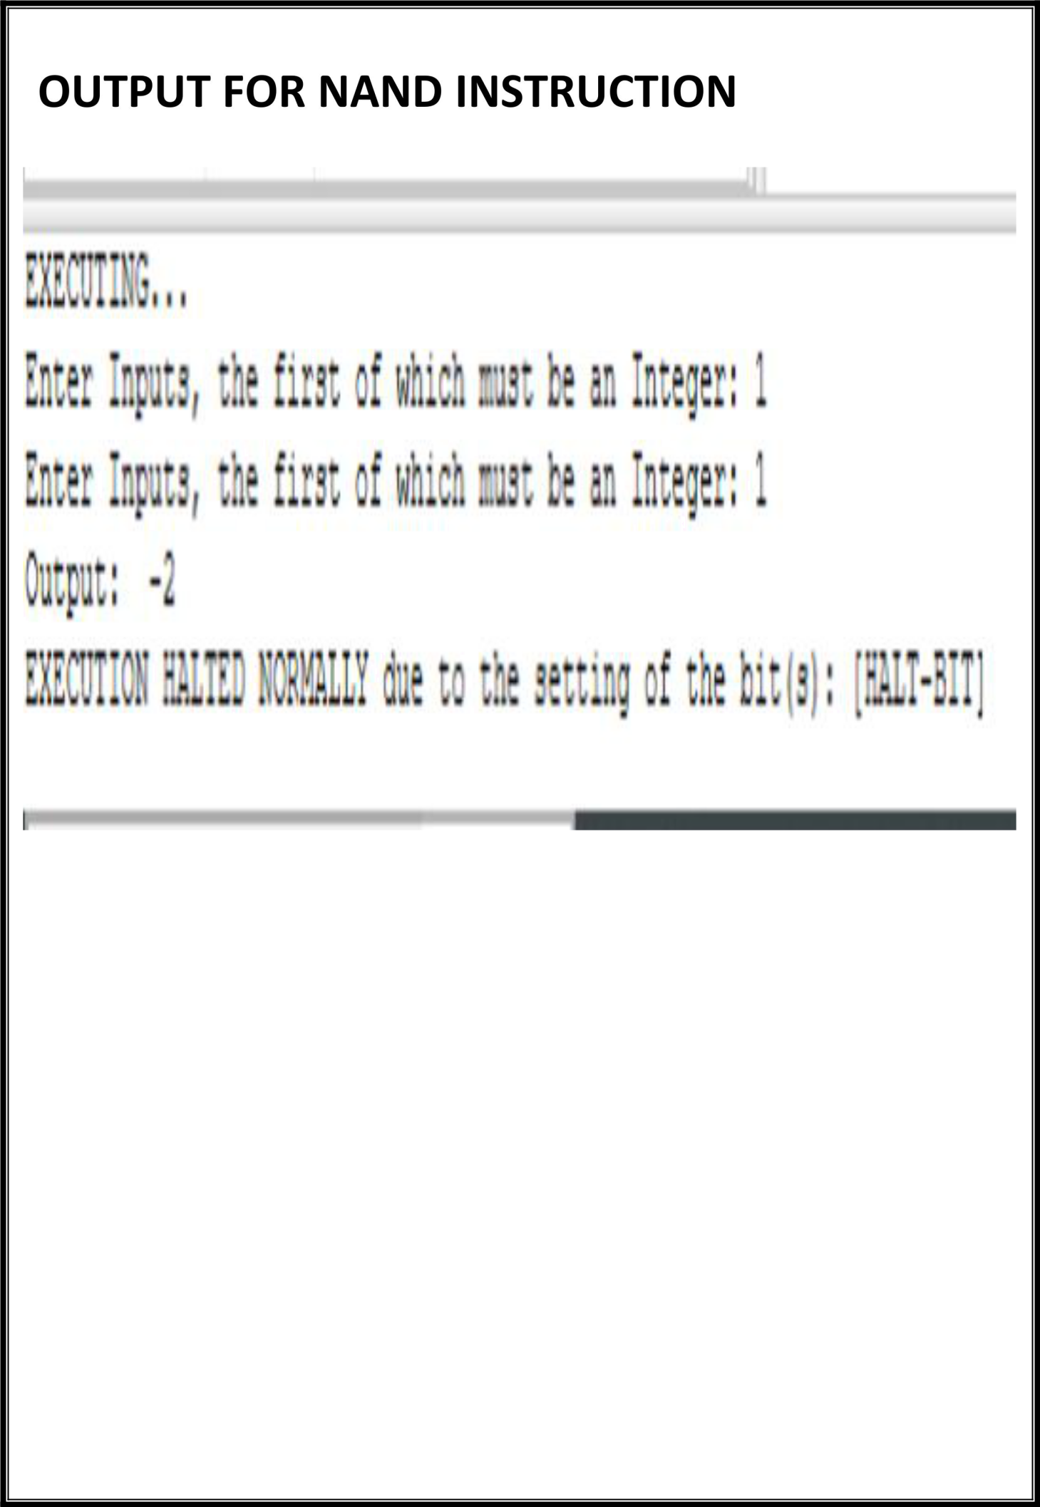

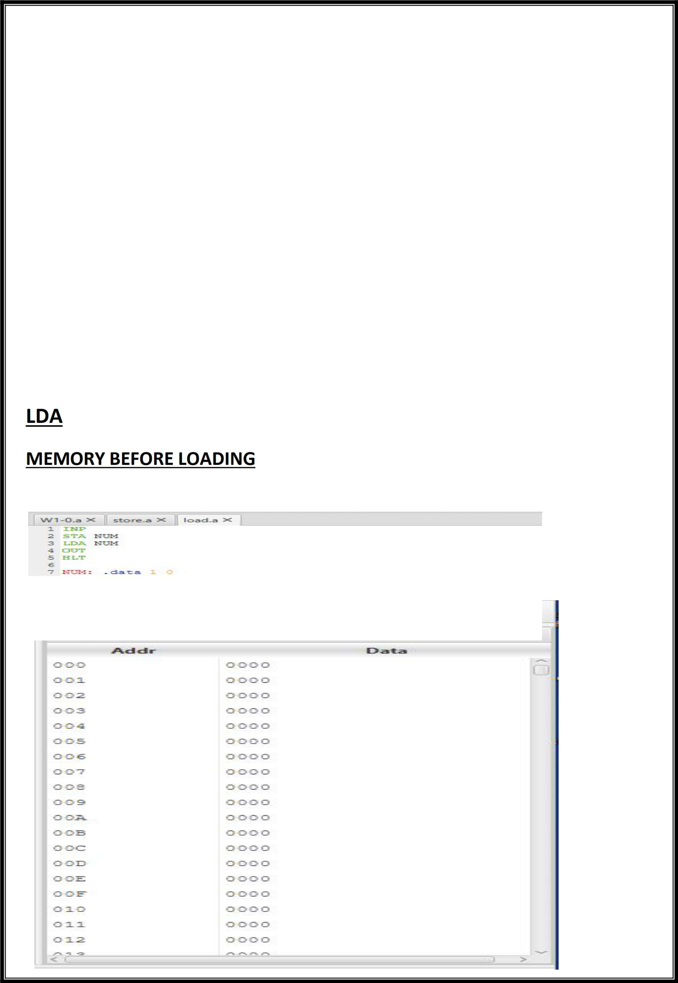

**PRACTICAL 6**

**Objective**

Write an assembly program for simulating following memory-reference instructions.

1. **ADD**
2. **LDA**
3. **STA**
4. **BUN**
5. **ISZ**

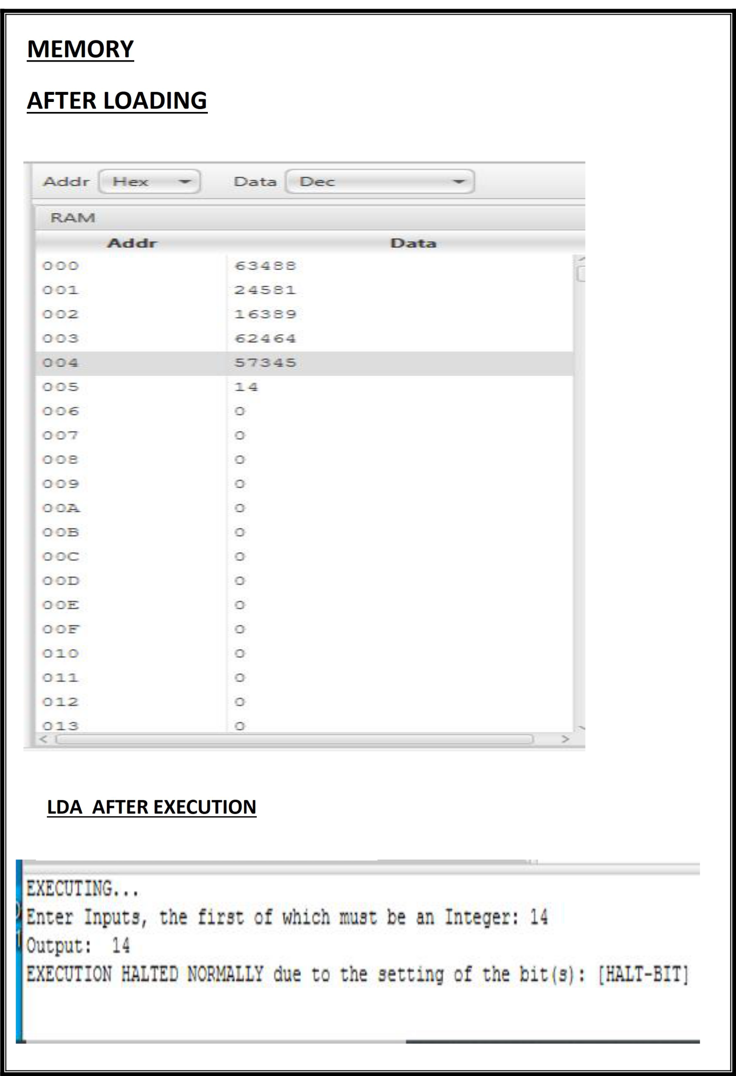

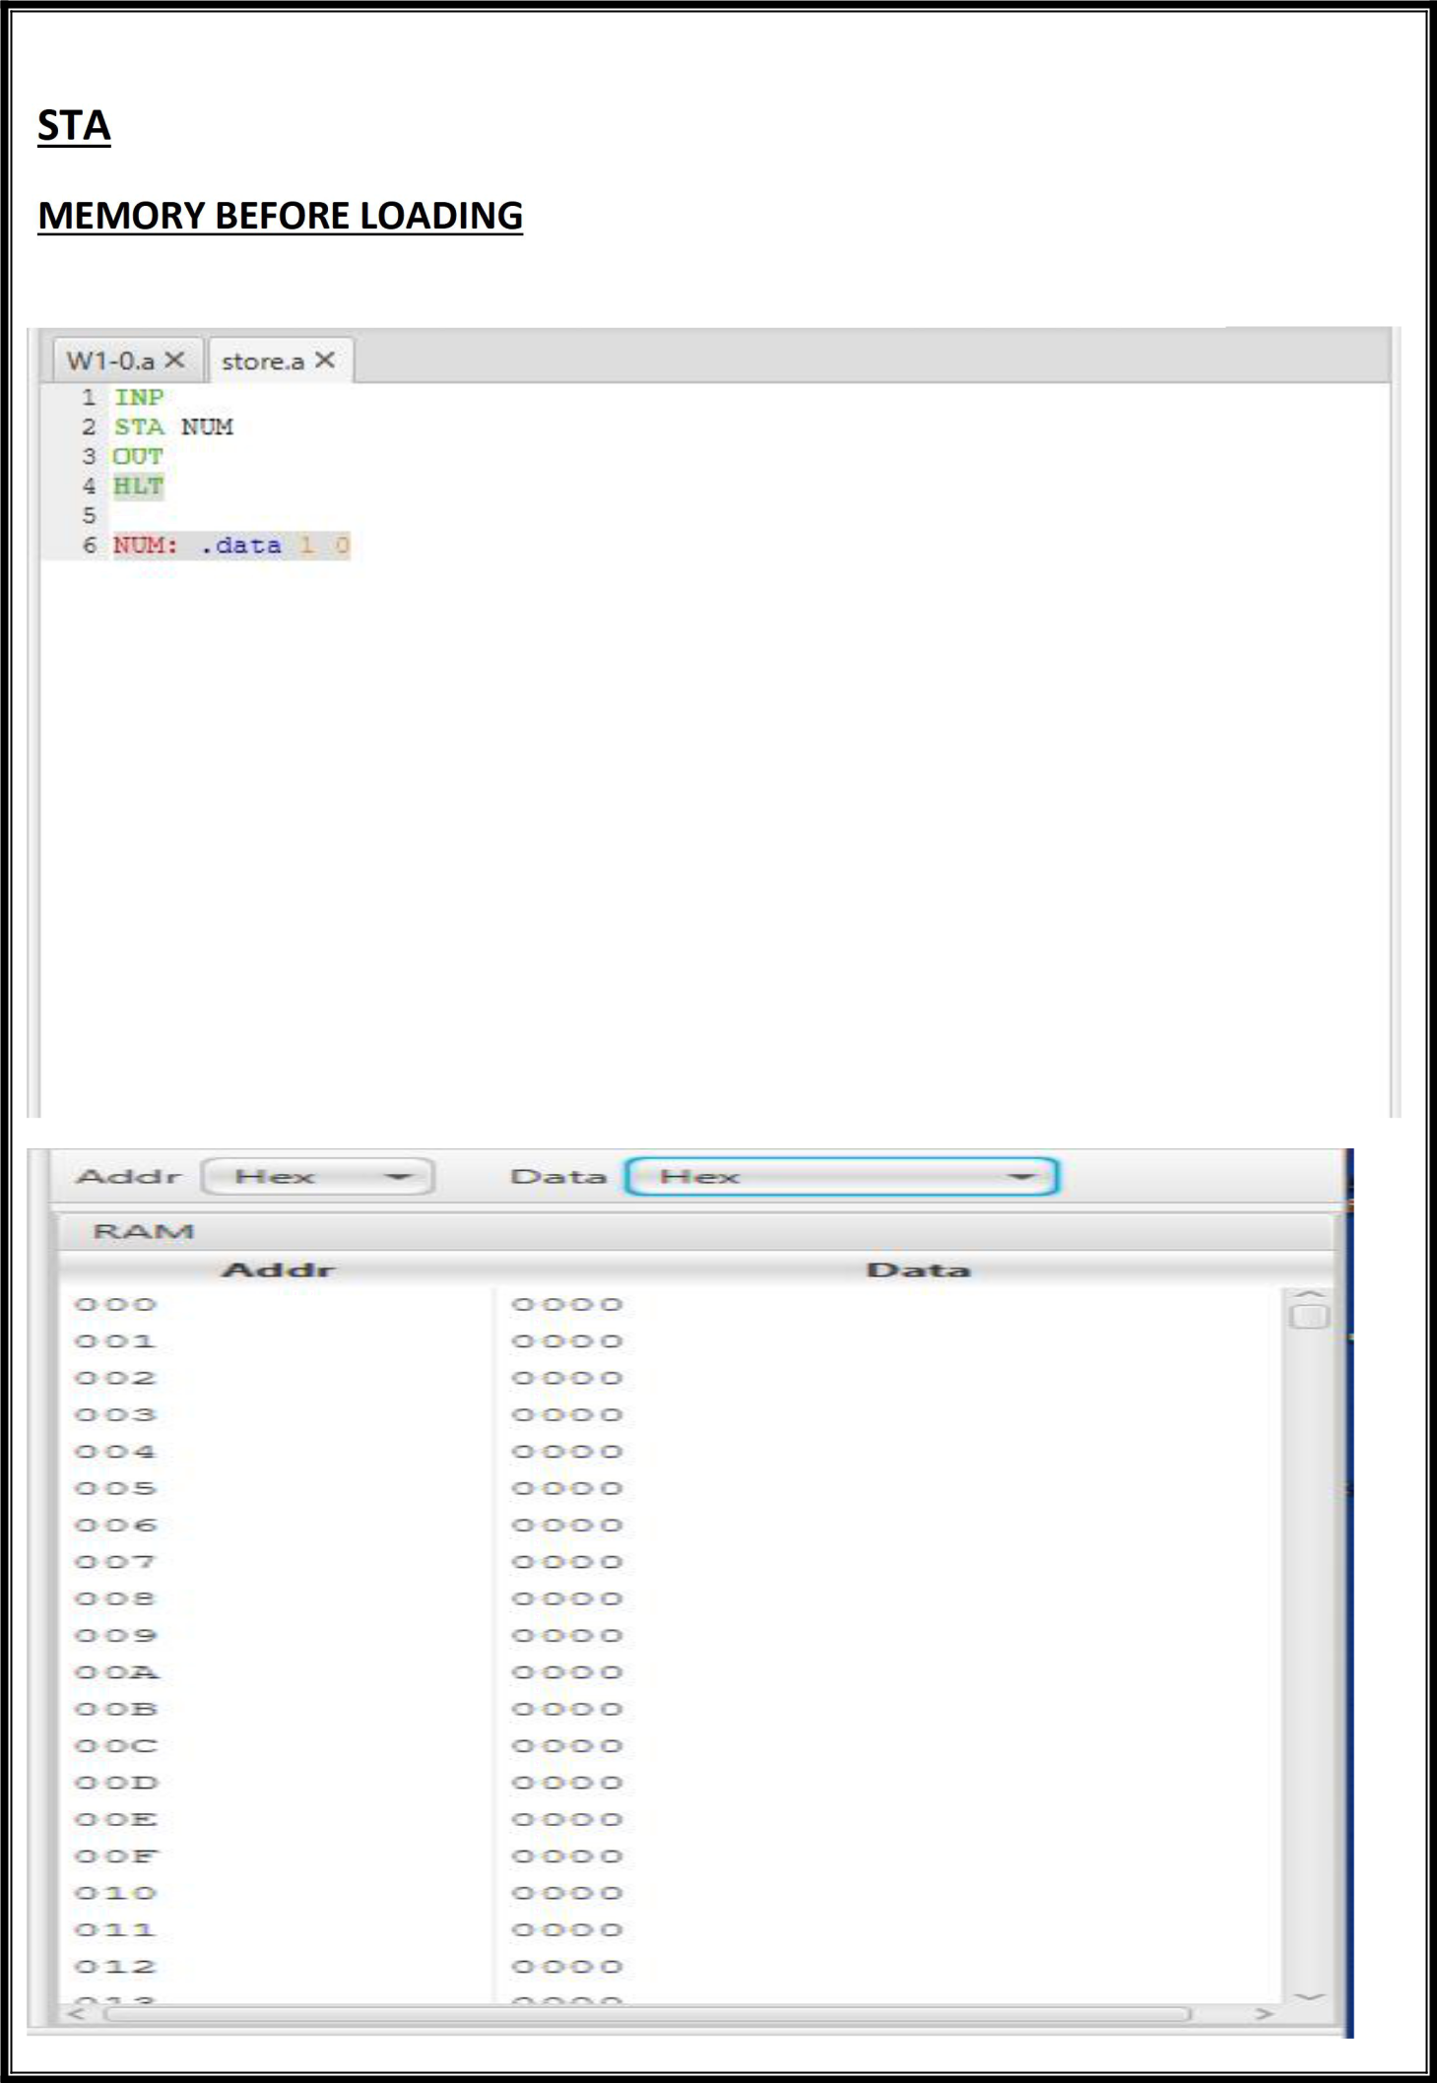

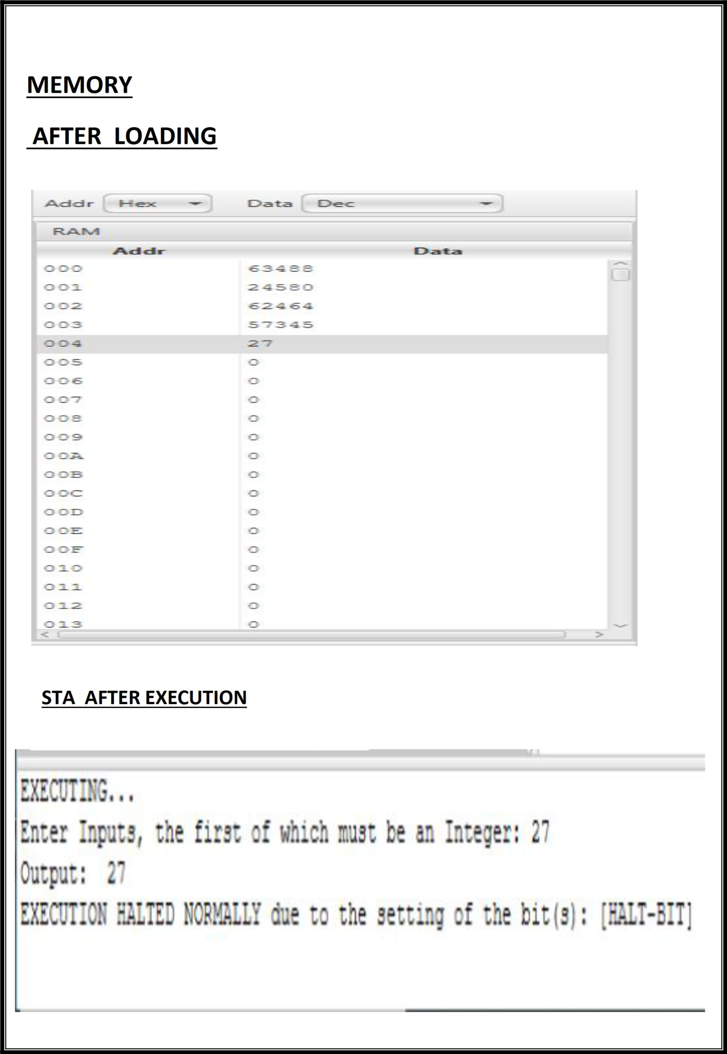

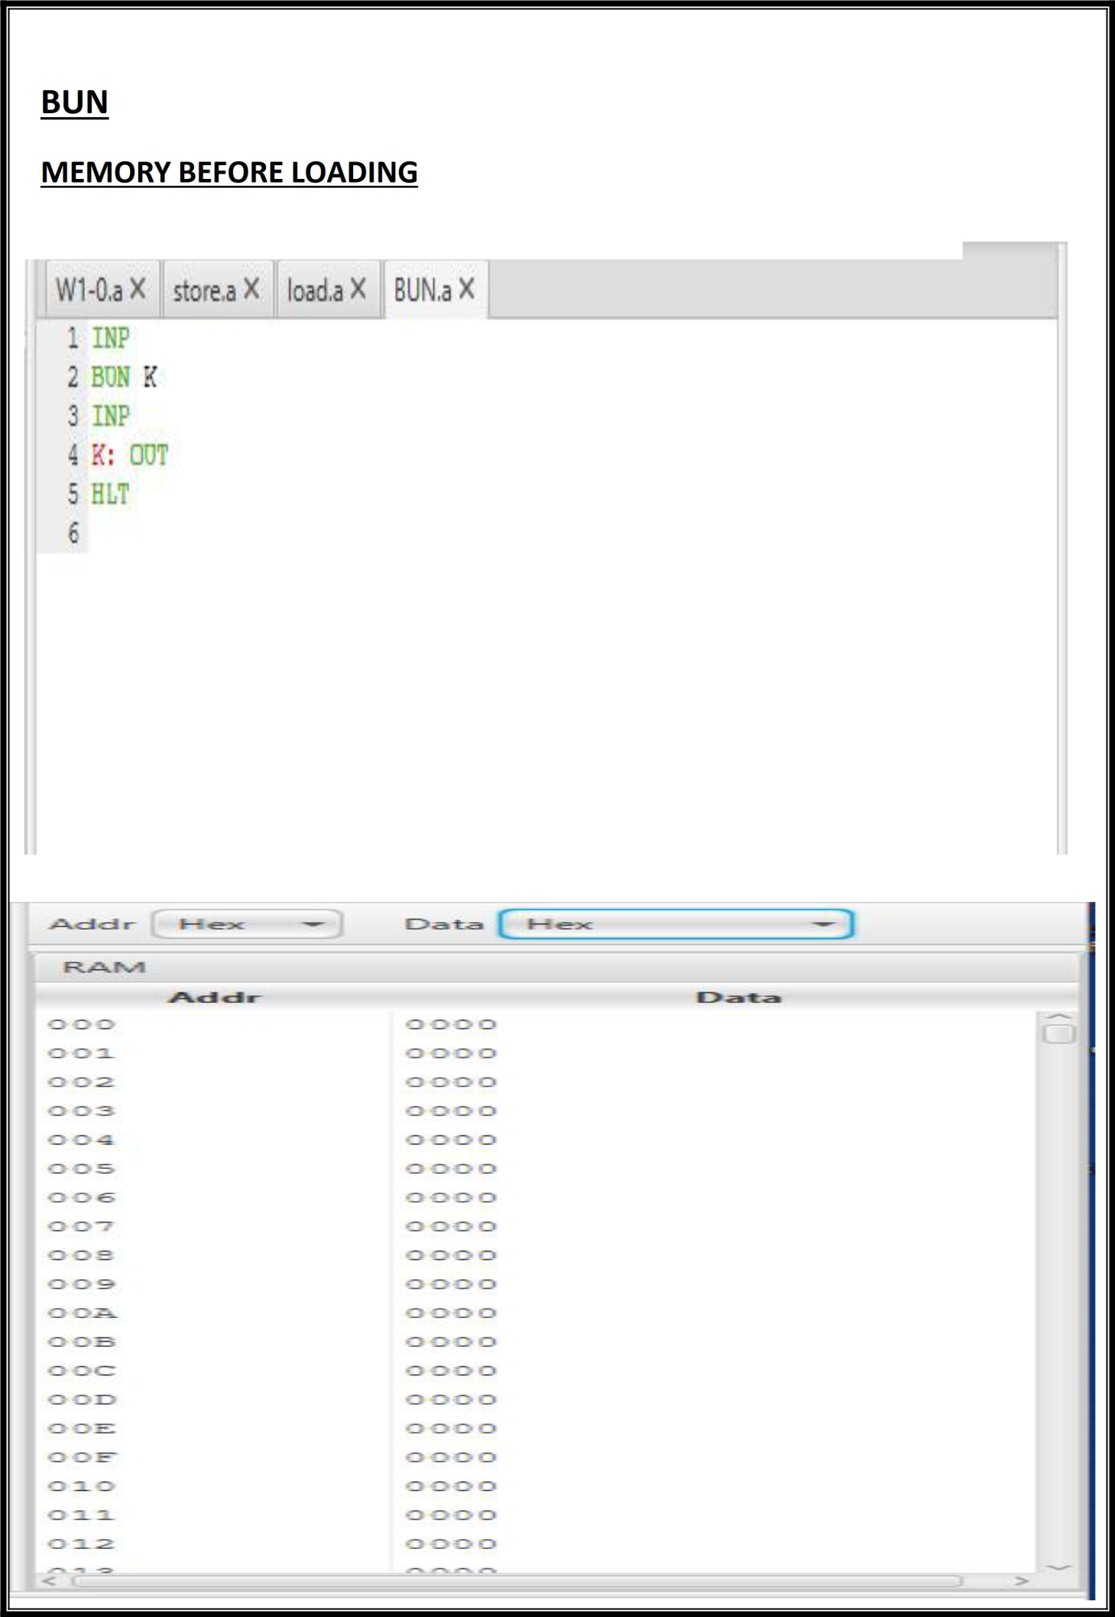

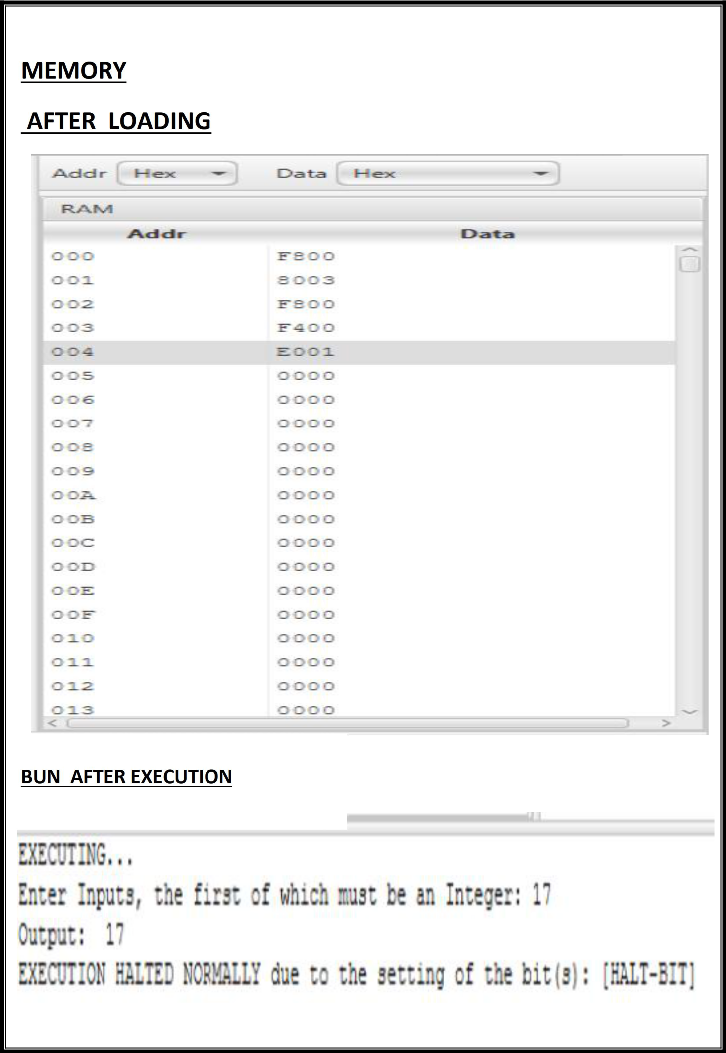

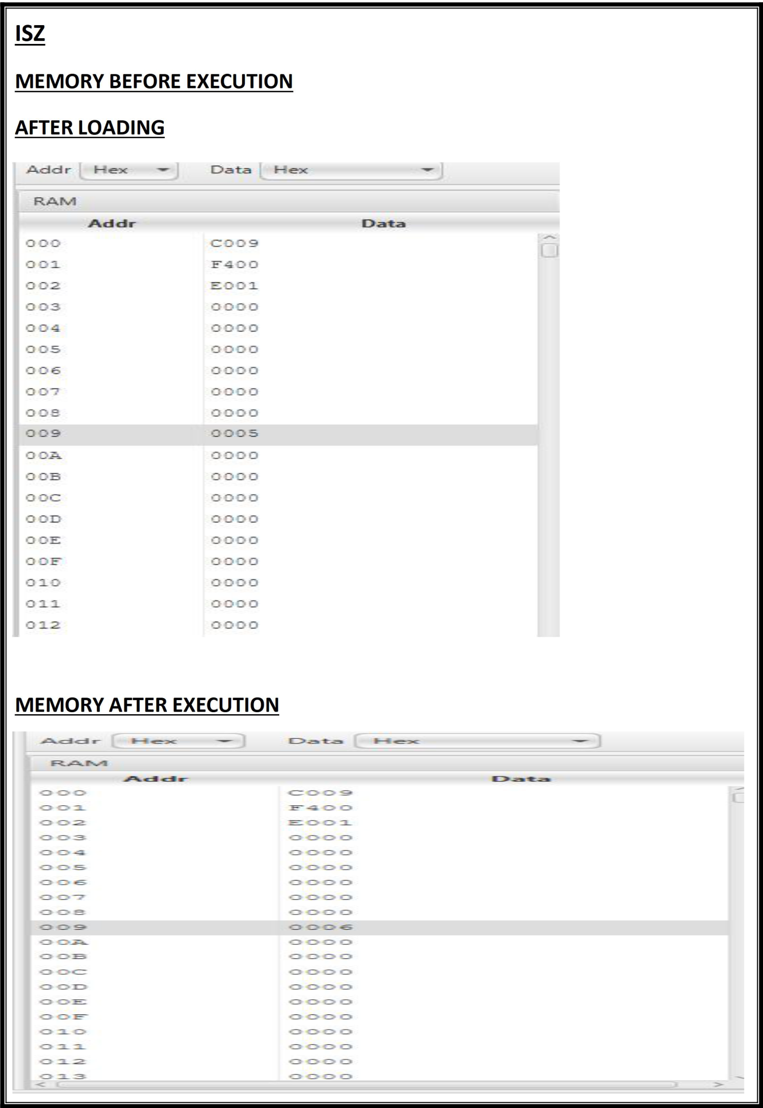

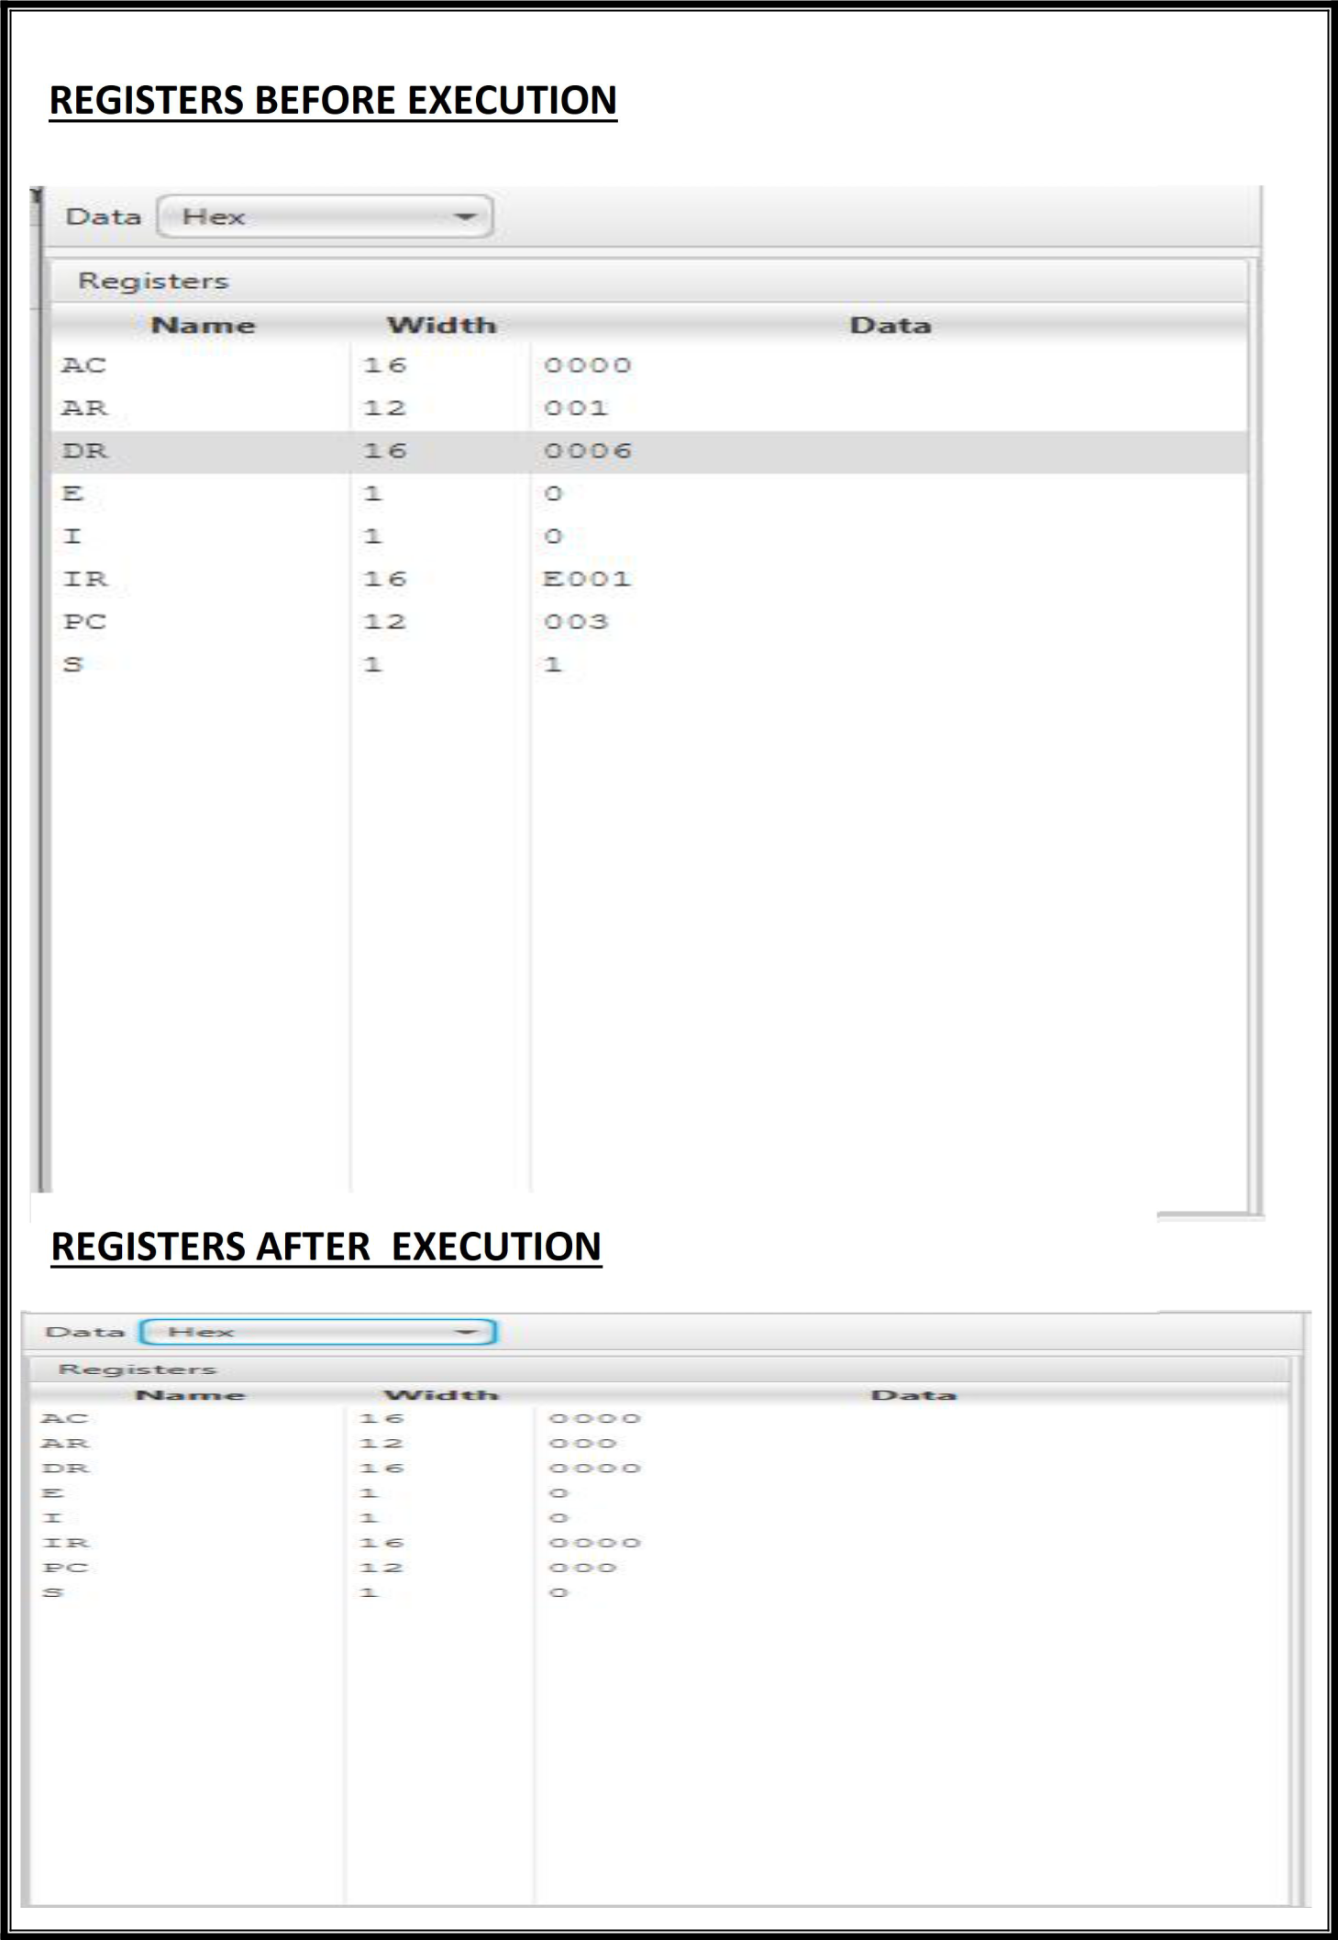

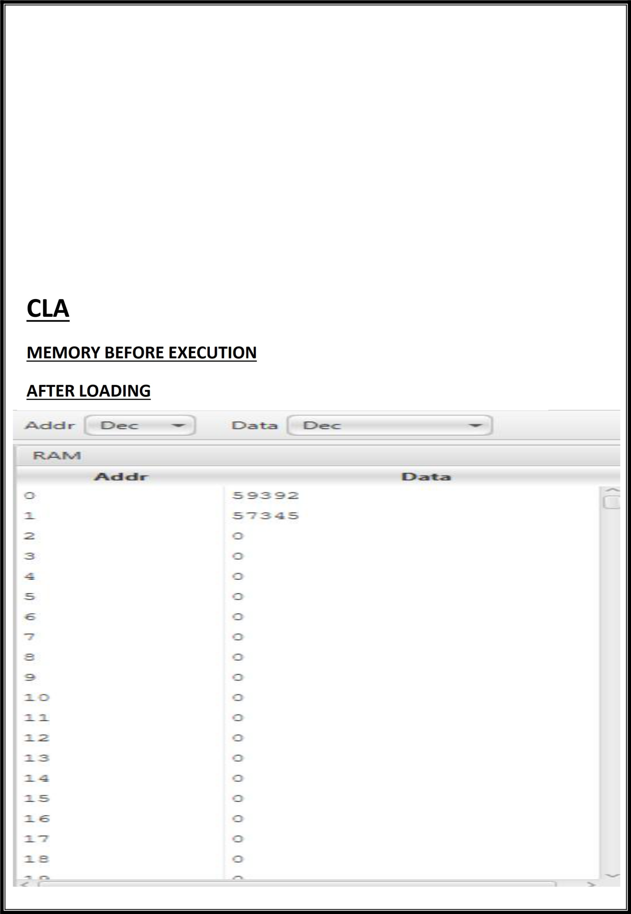**PRACTICAL 7**

**Objective**

Write an assembly program for simulating following memory-reference instructions.

1. **CLA**
2. **CMA**
3. **CME**
4. **HLT**

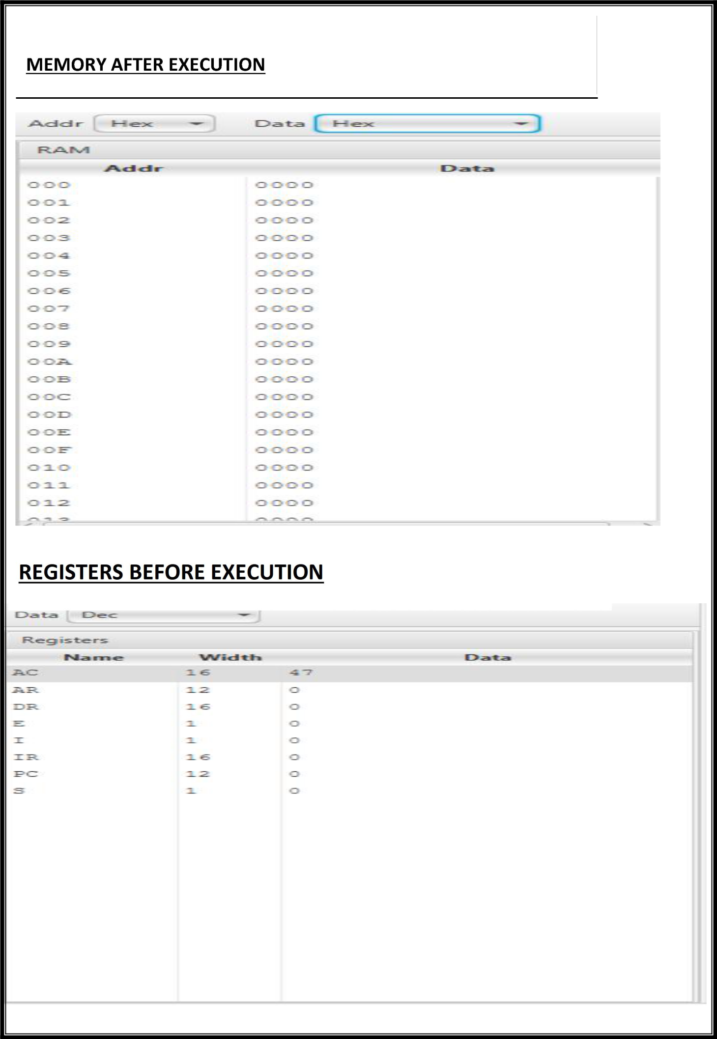

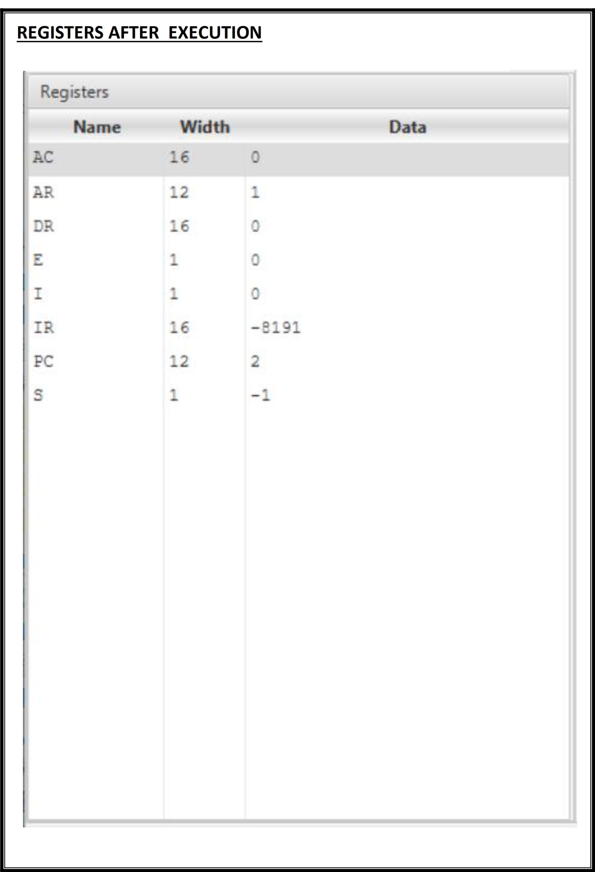

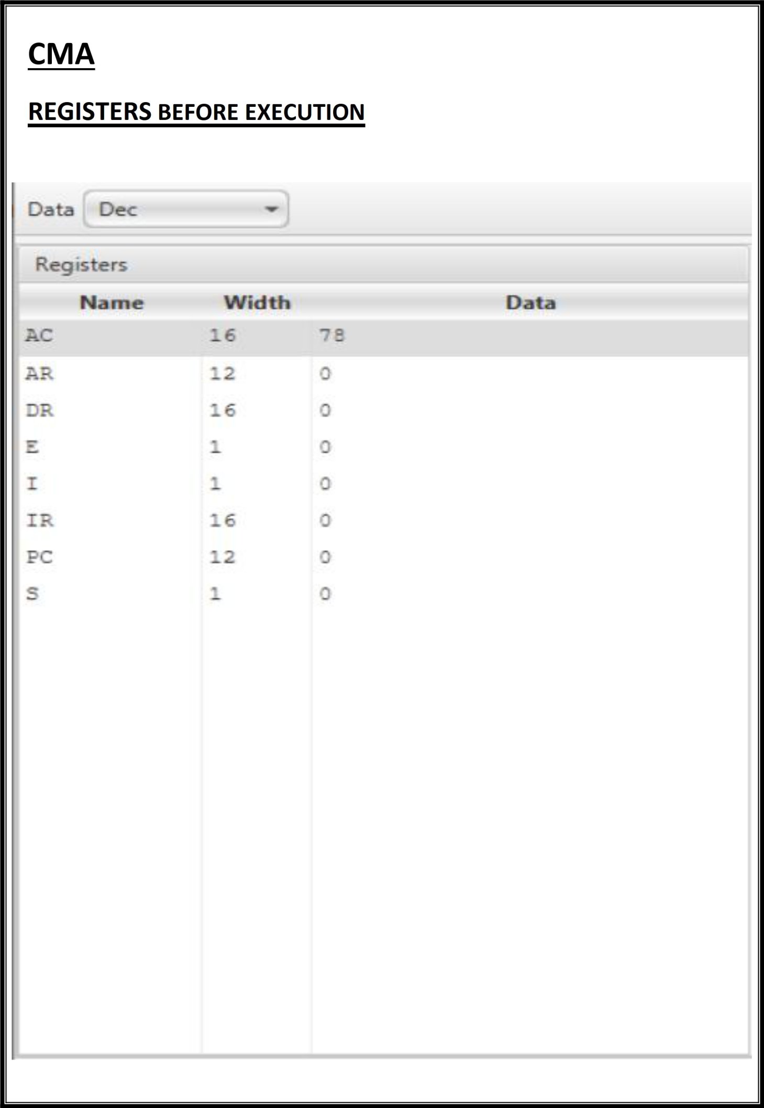

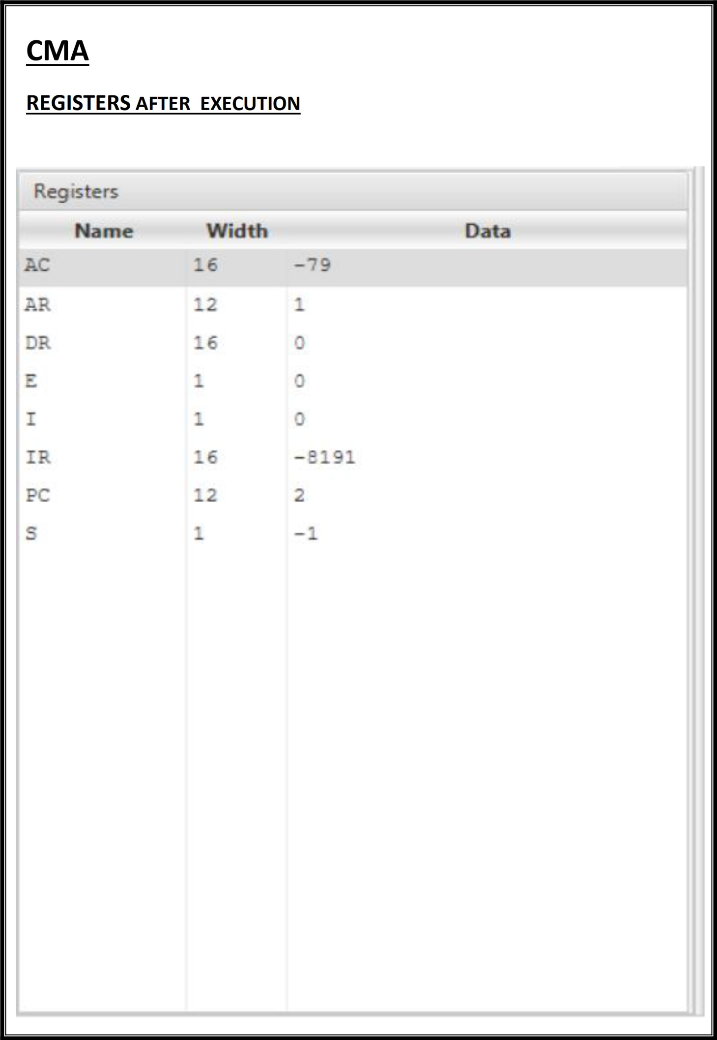

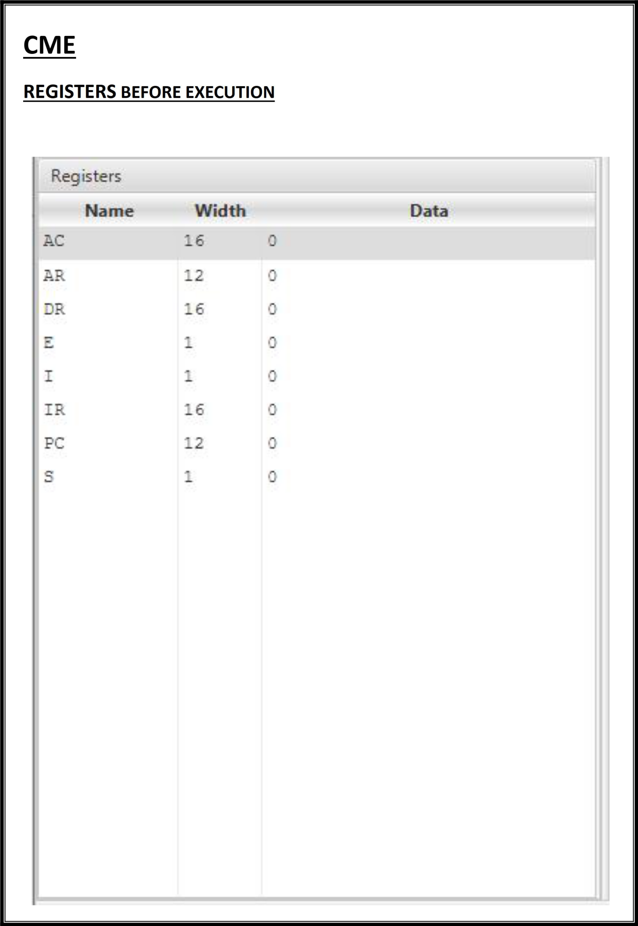

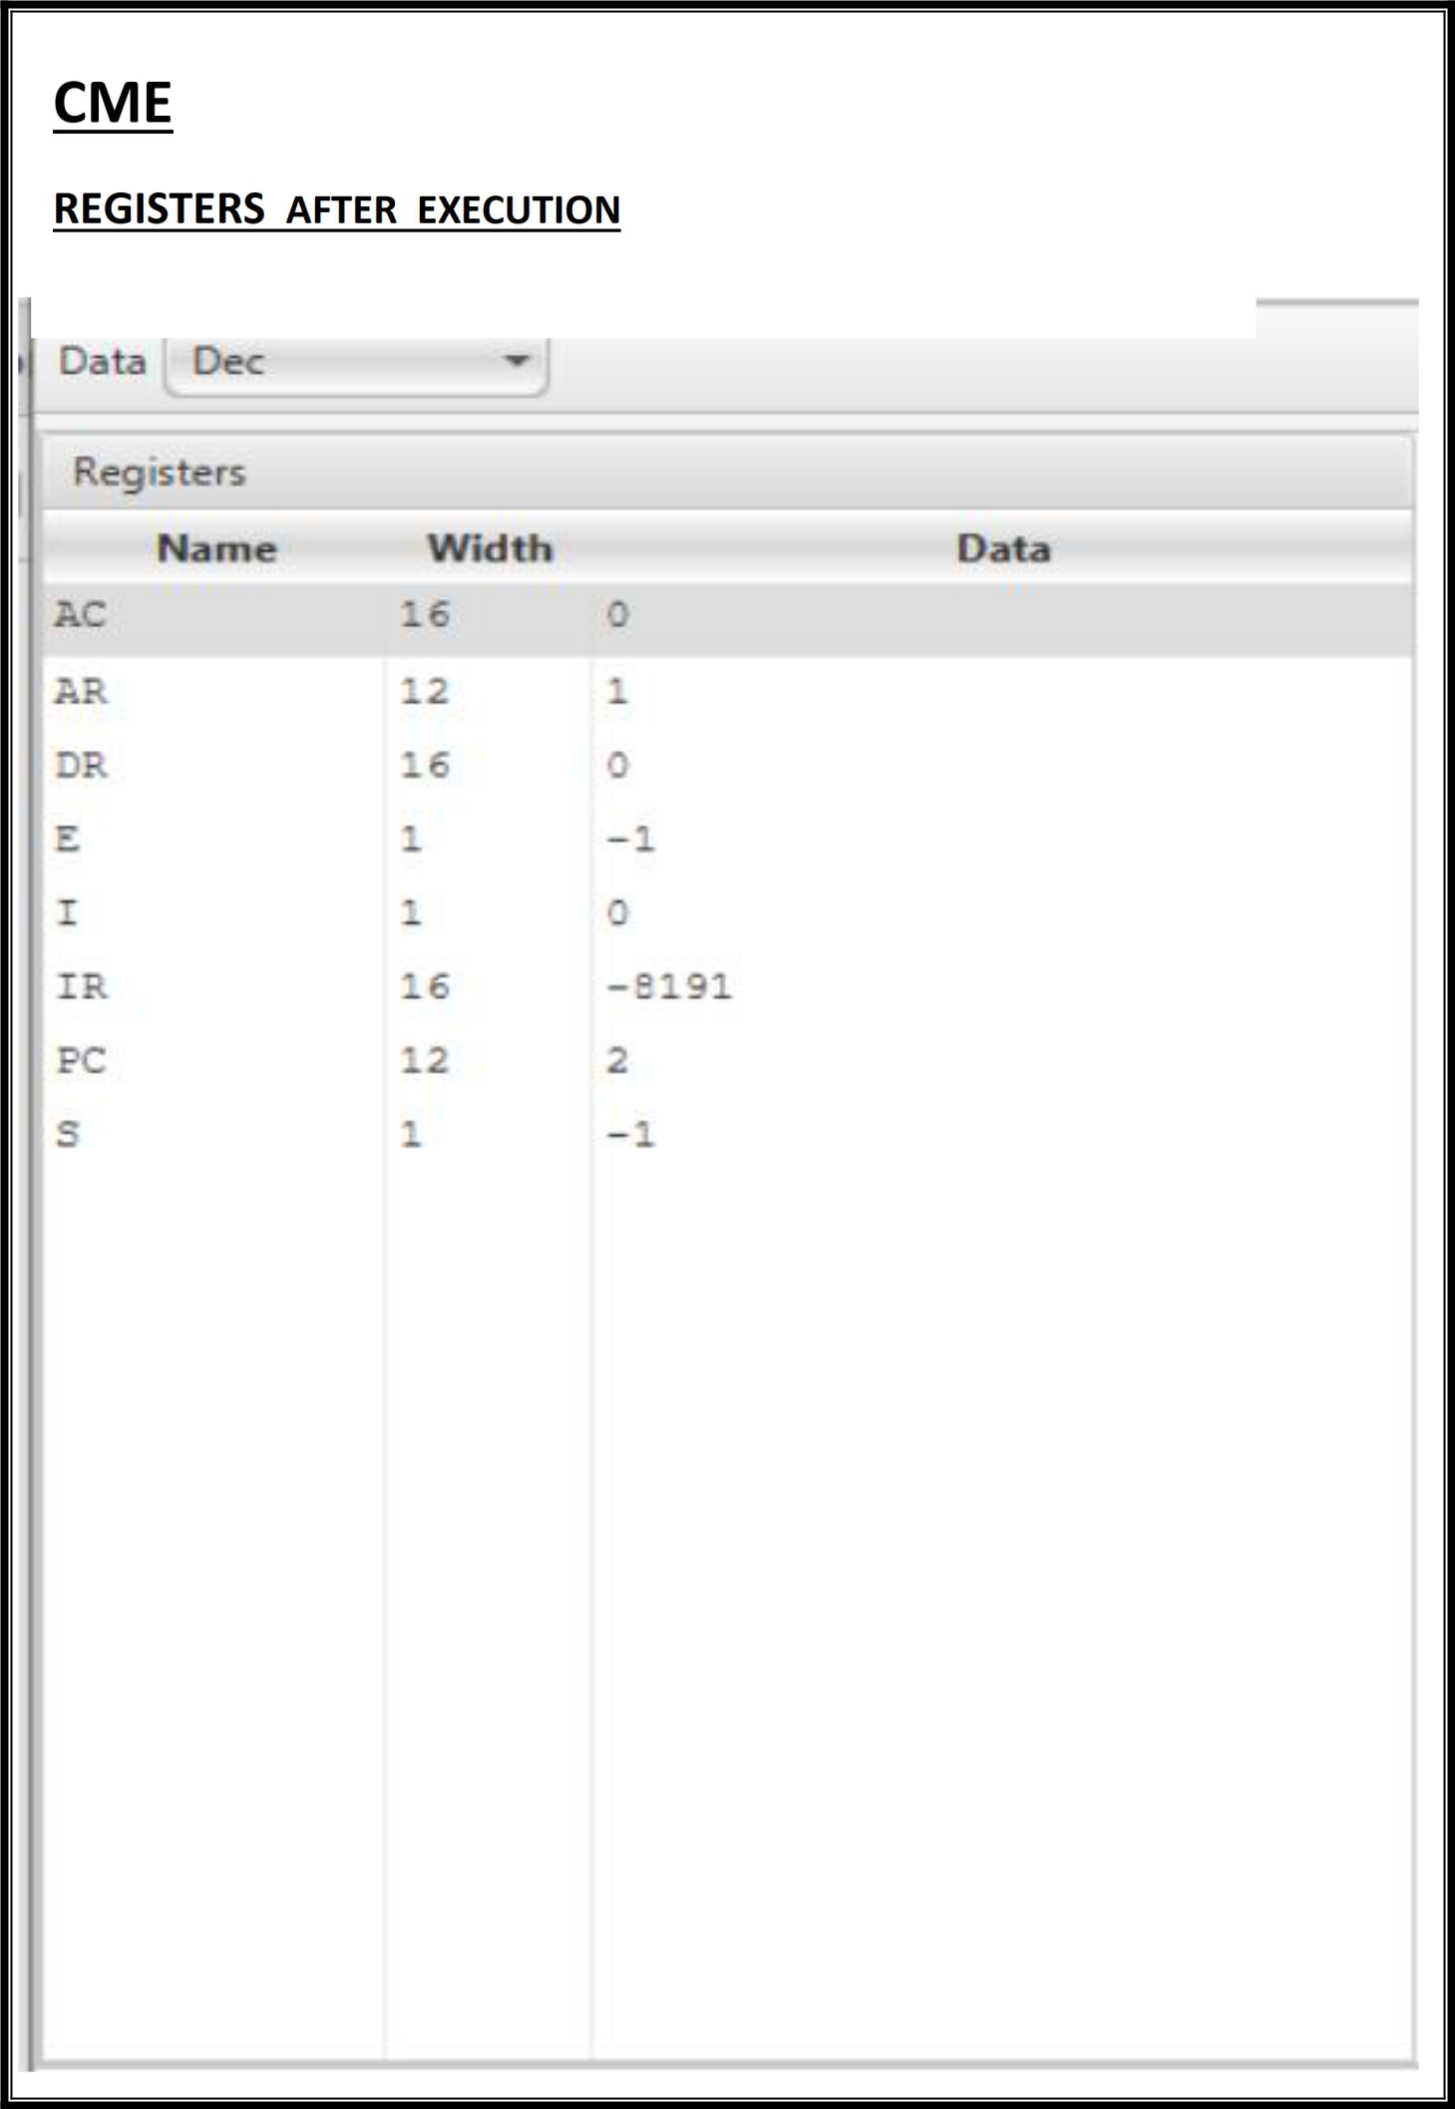

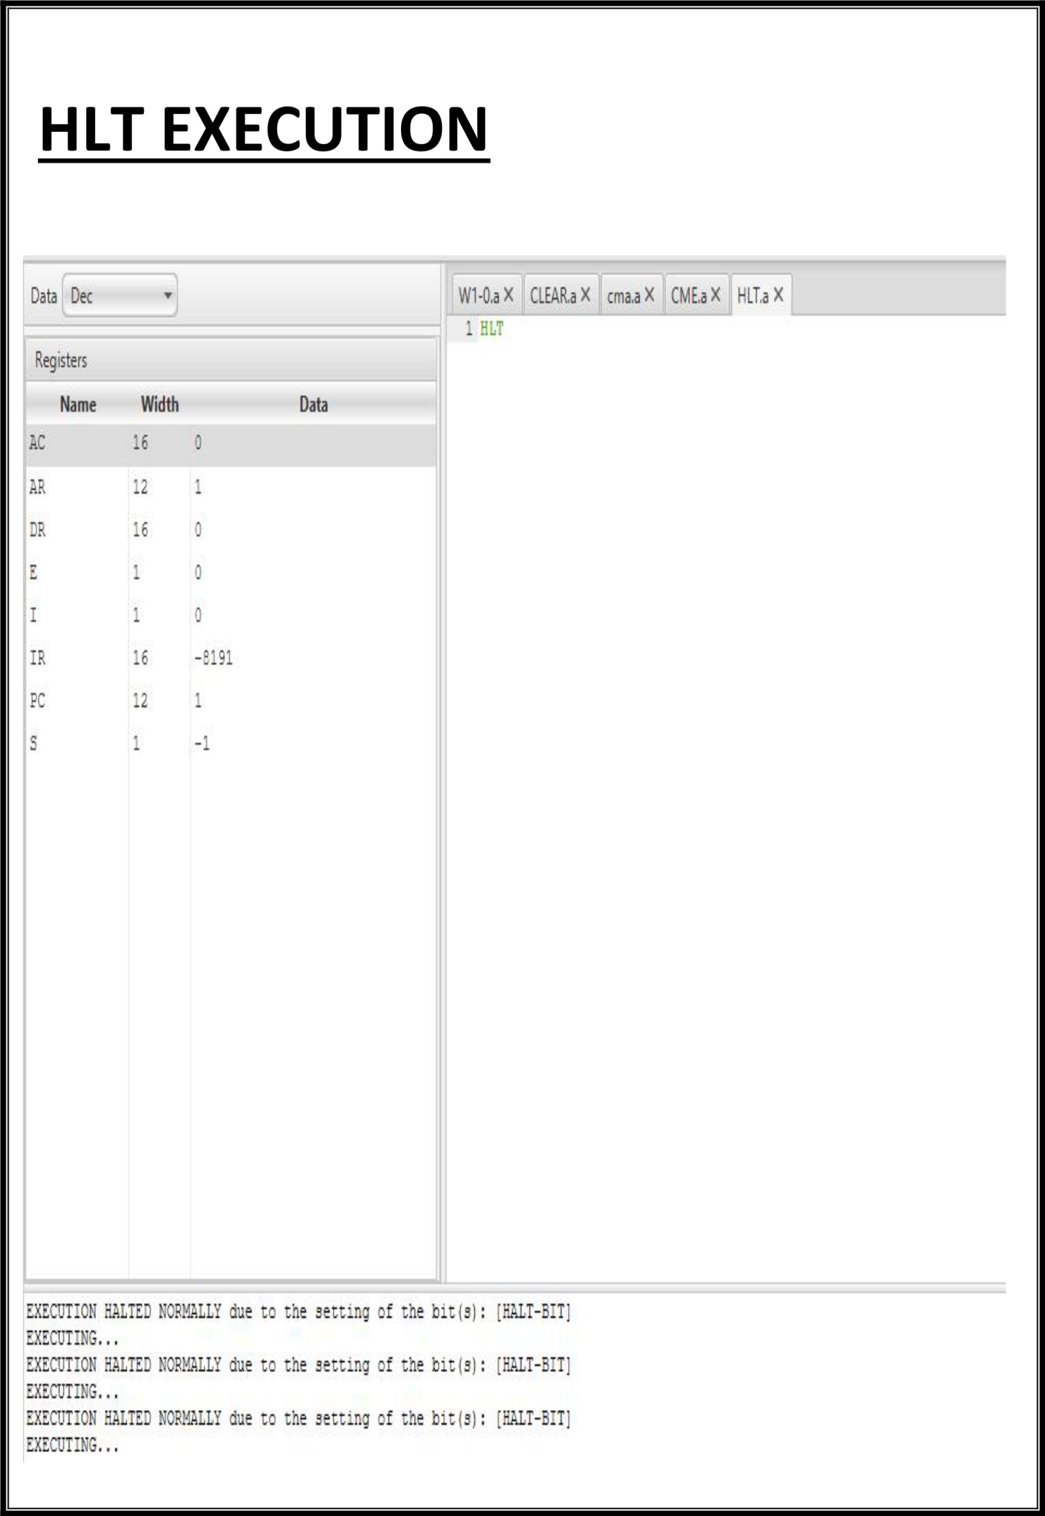

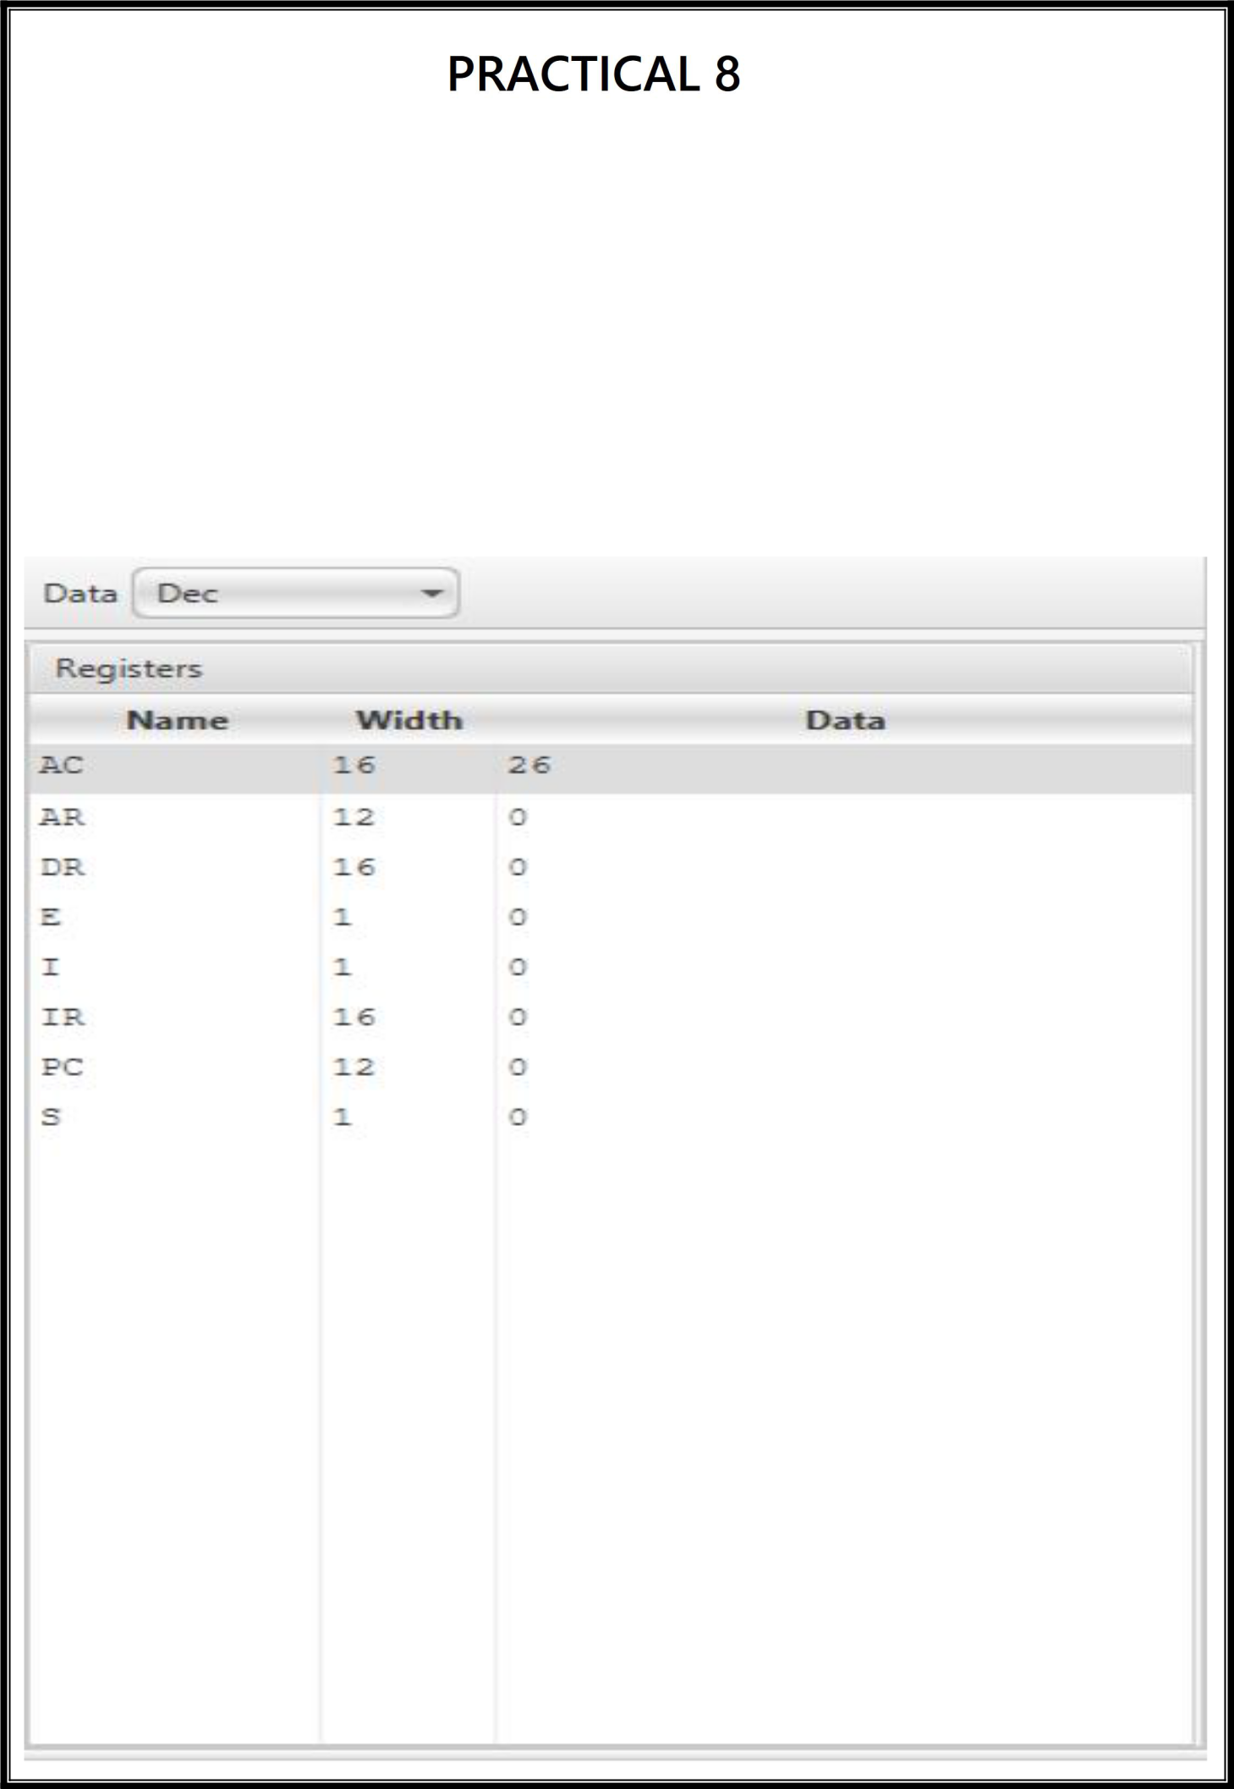

**Objective**

Write an assembly language program to simulate the machine for following register

reference instructions.

1. **INC**
2. **SPA**
3. **SNA**
4. **SZE**

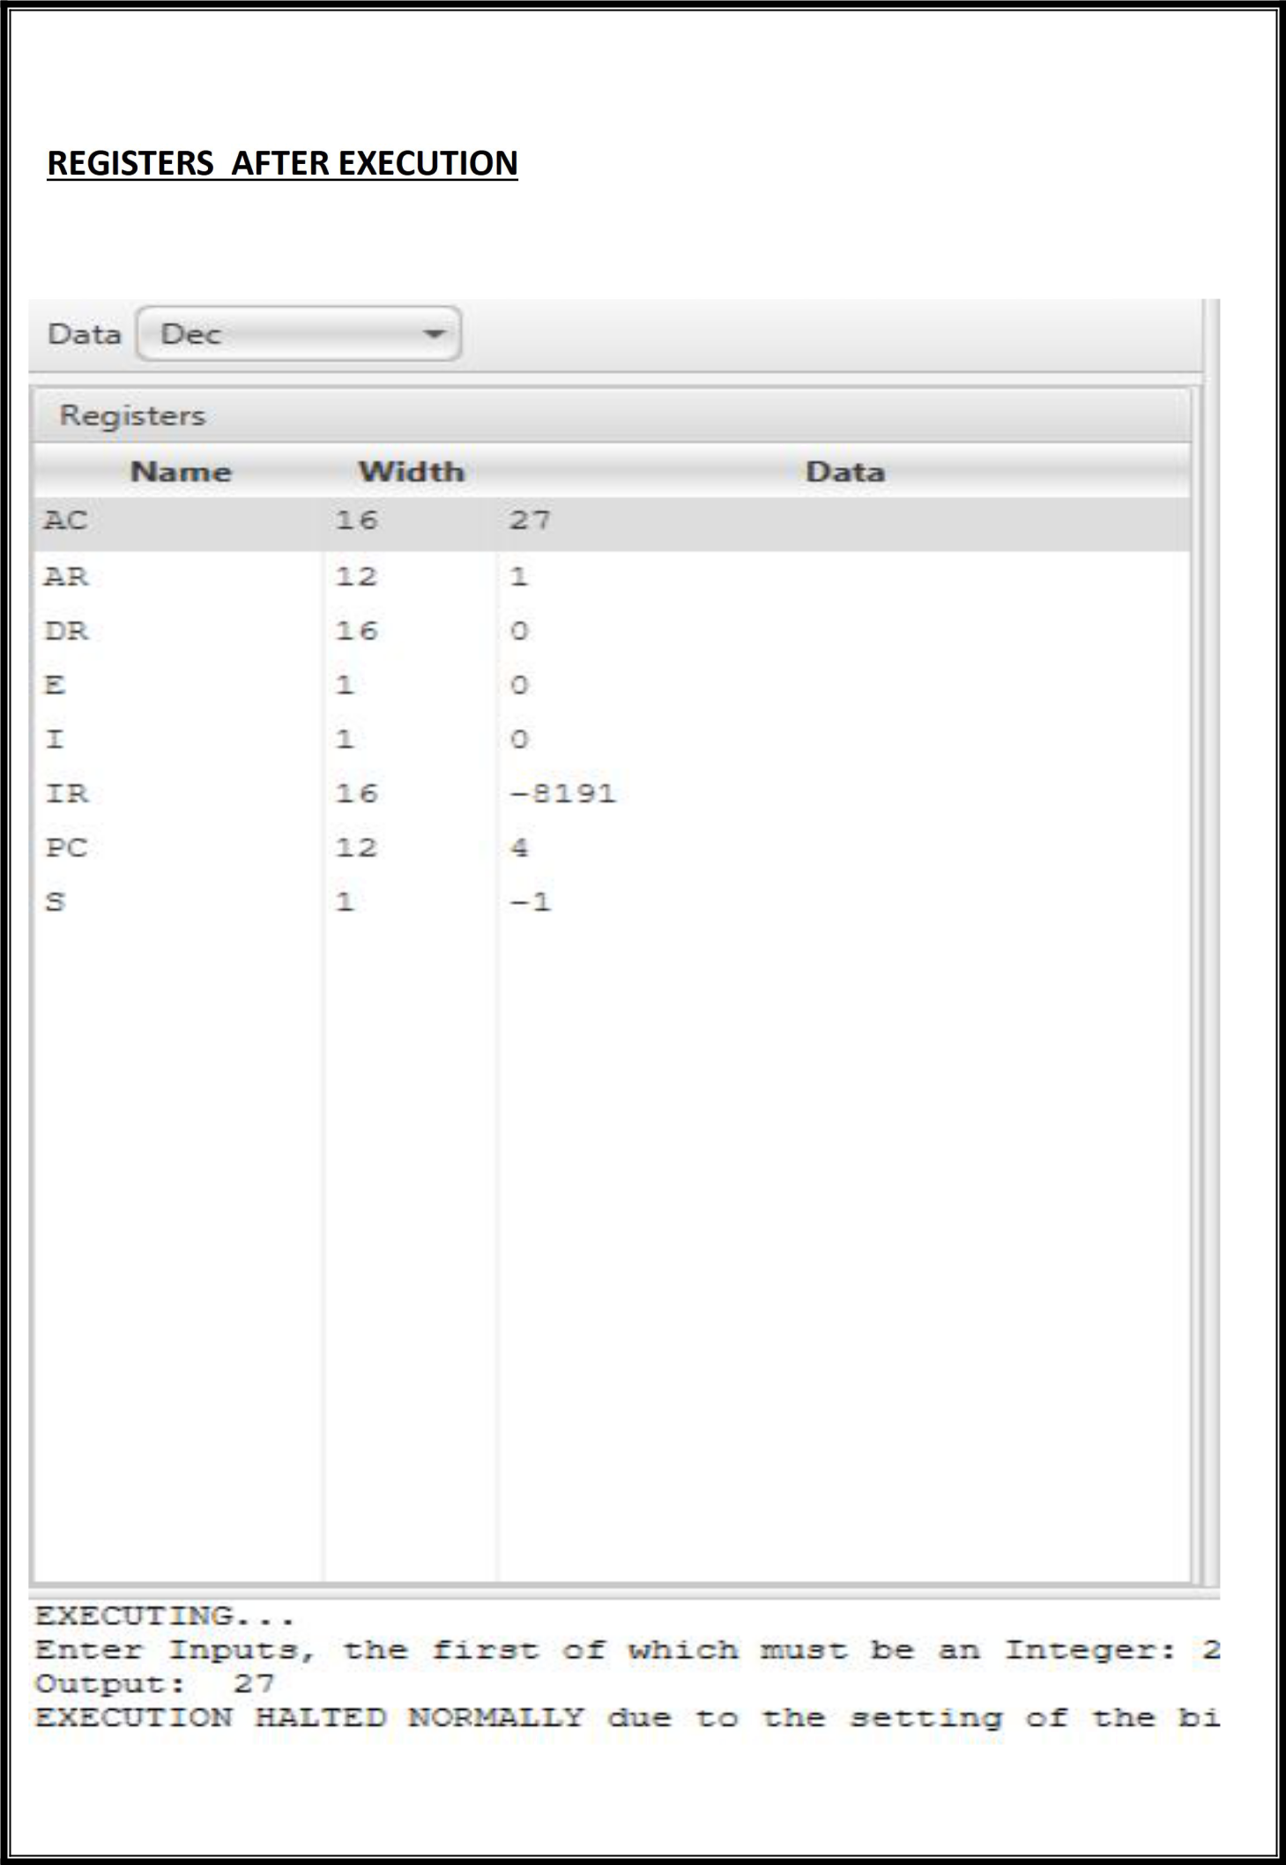

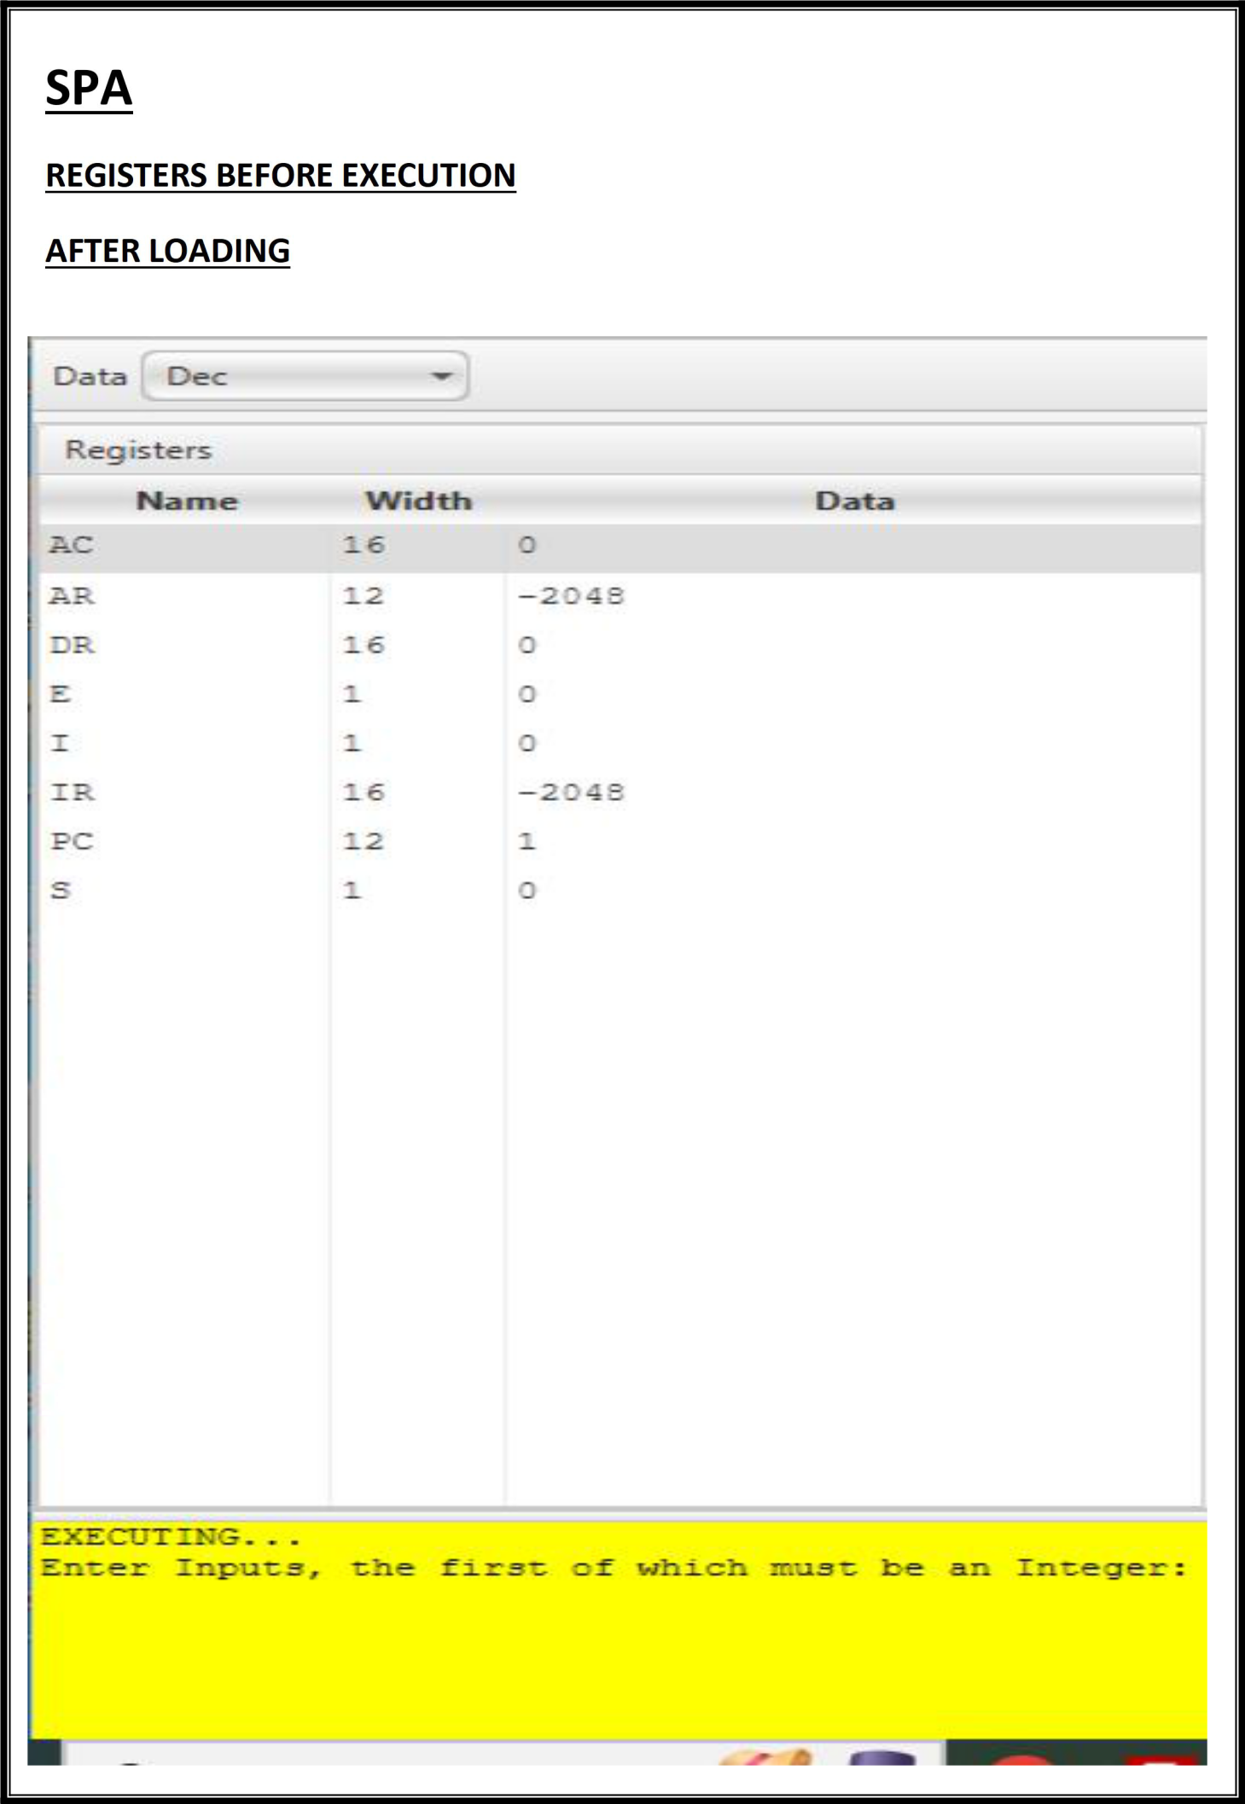

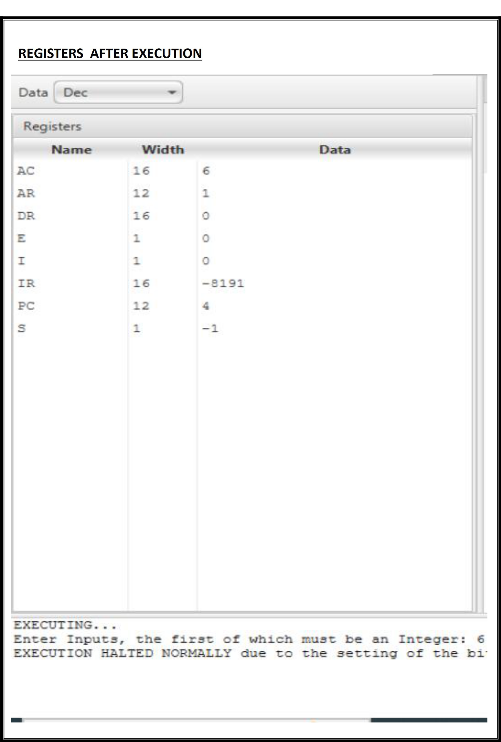

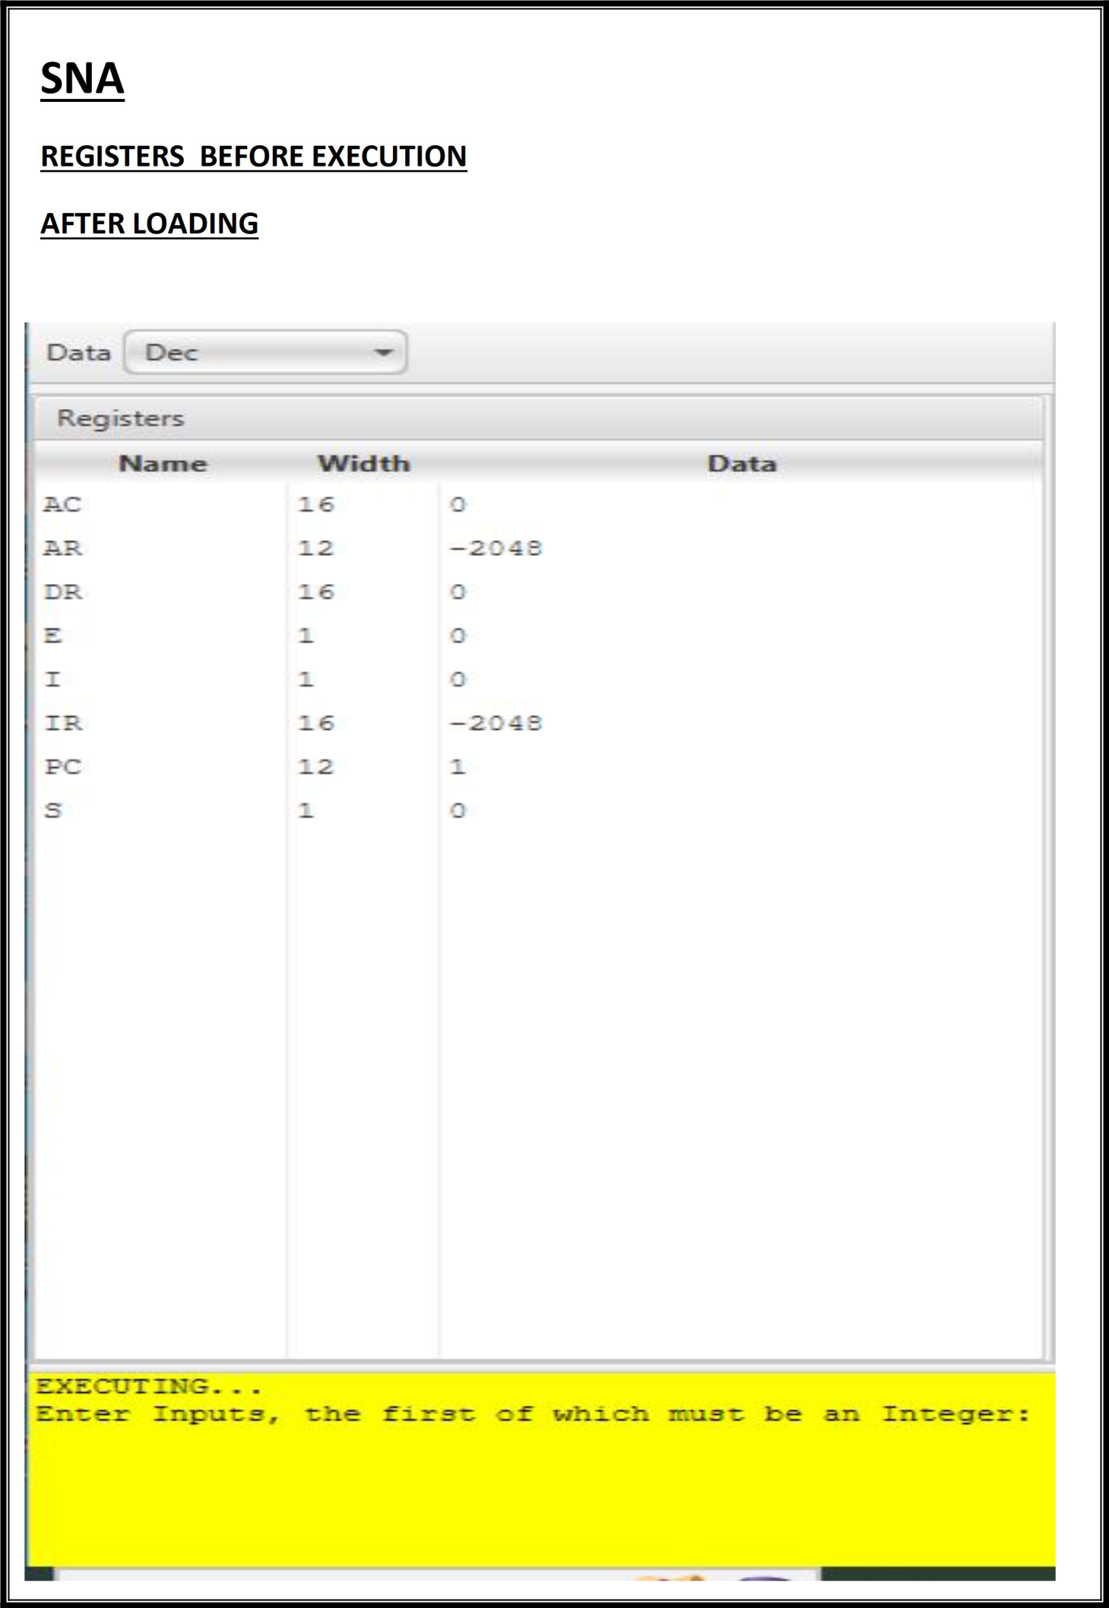

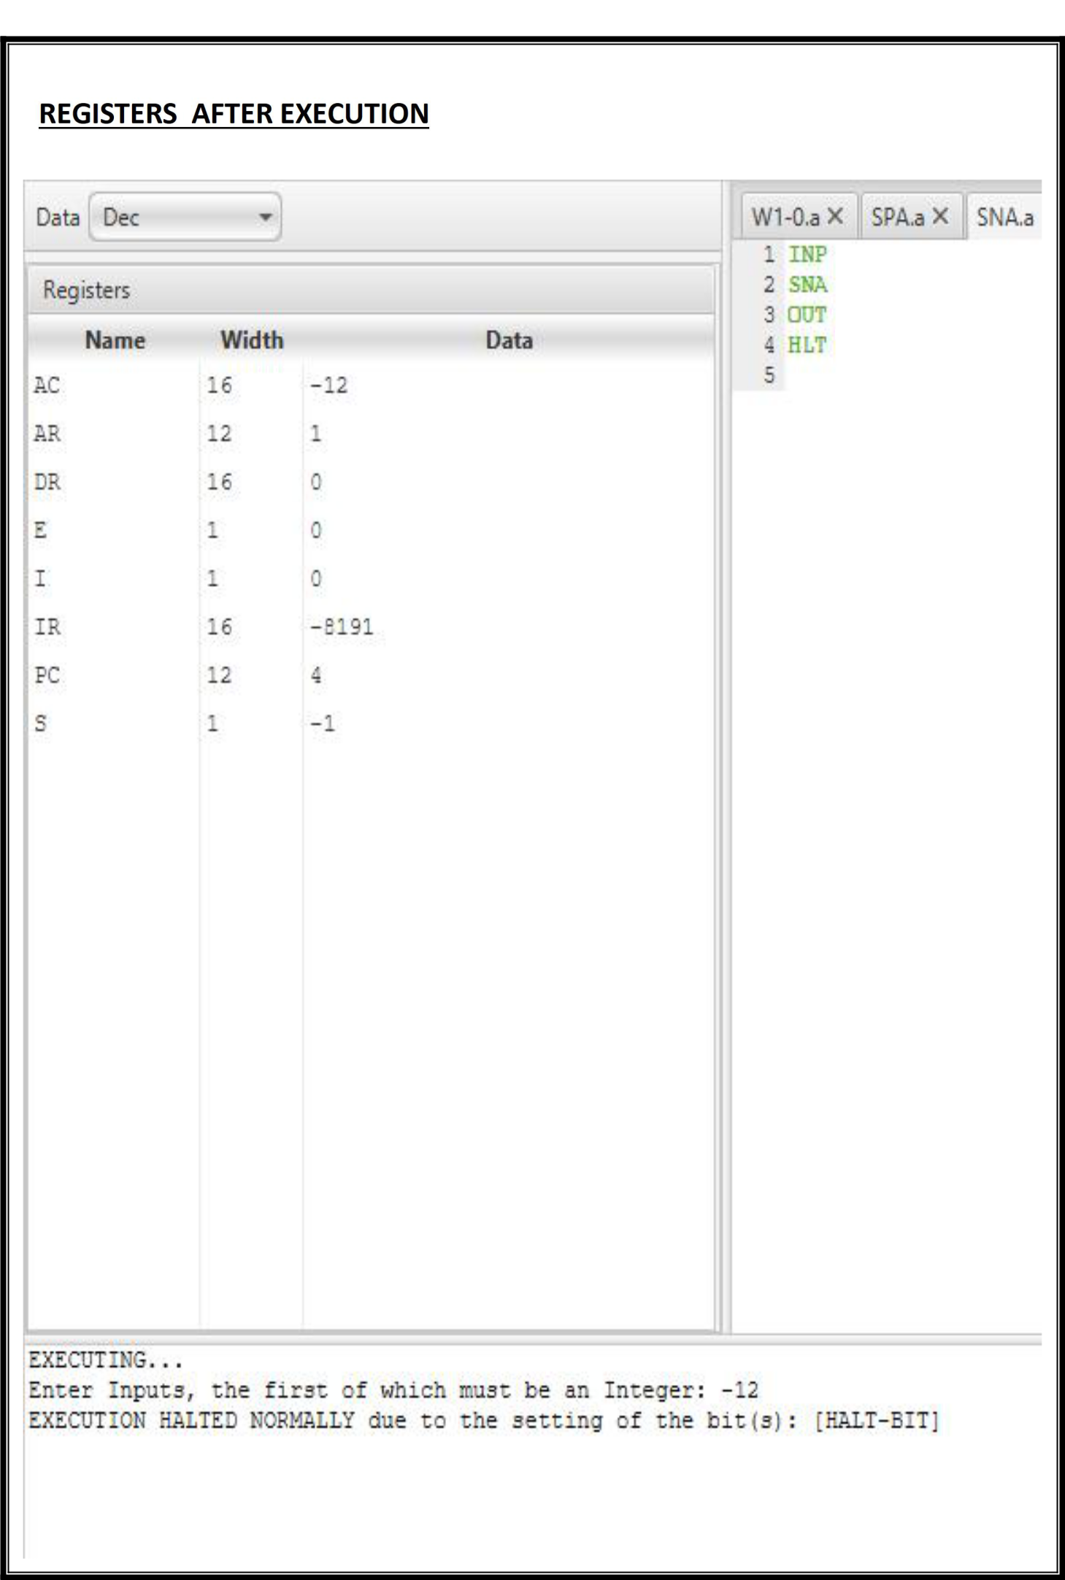

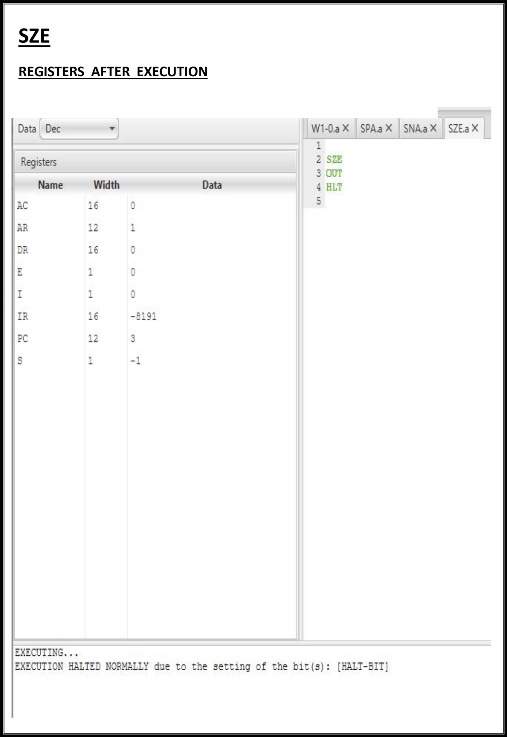

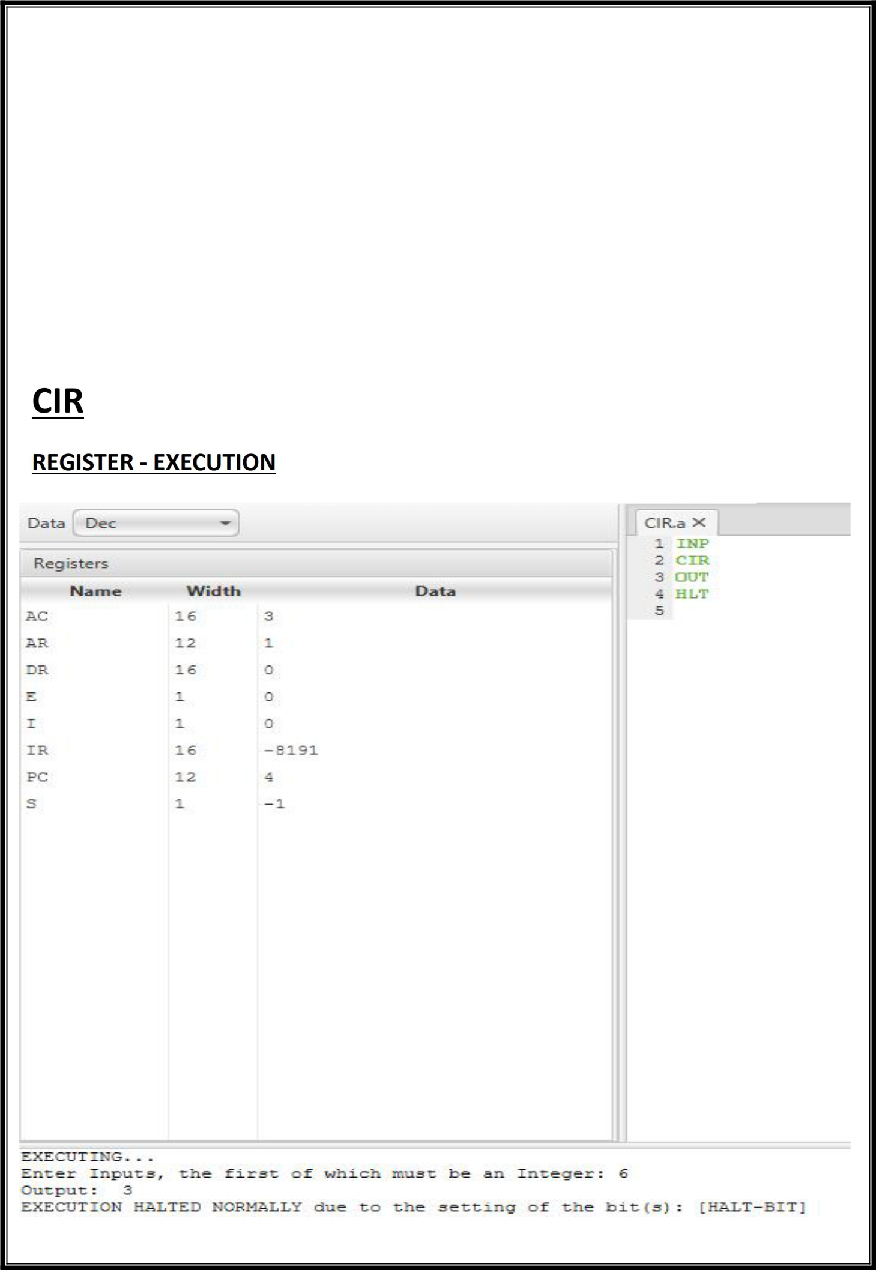**PRACTICAL-**9

**Objective**

Write an assembly language program to simulate the machine for following register

reference instructions.

1. **CIR**
2. **CIL**

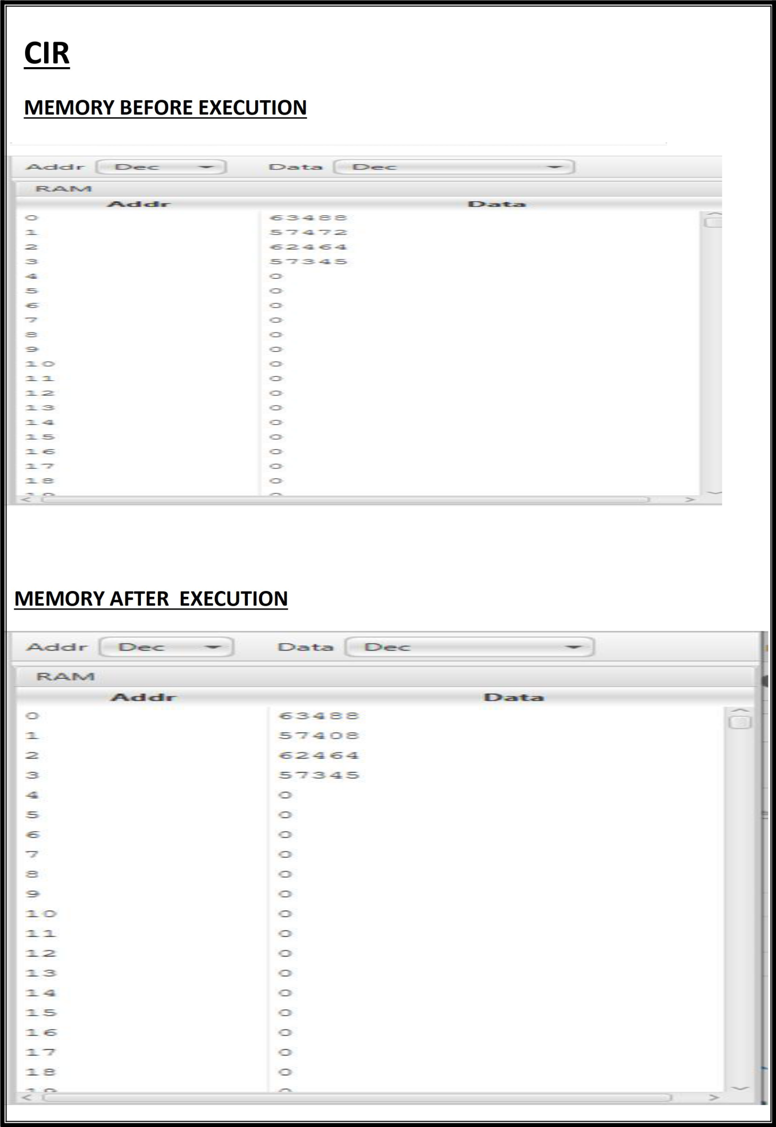

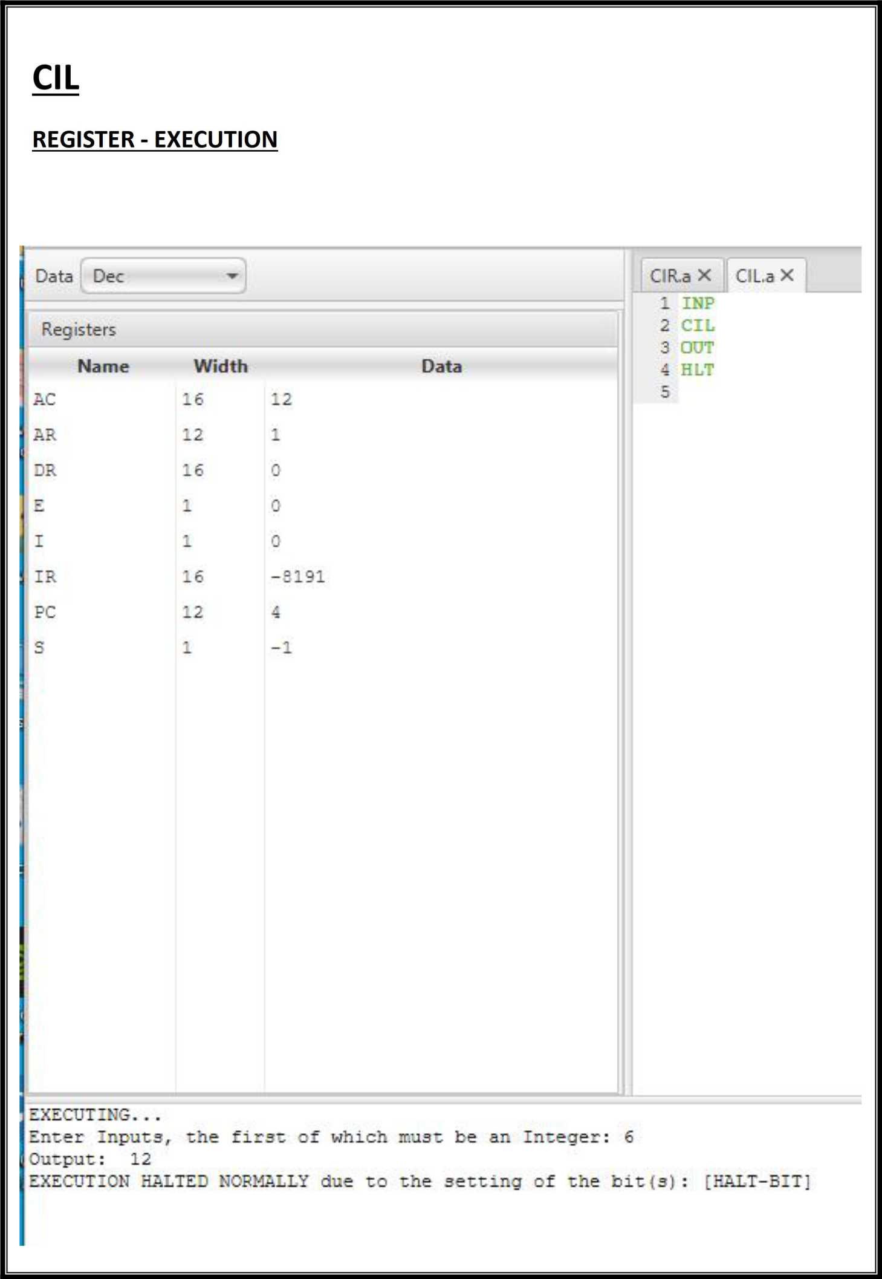

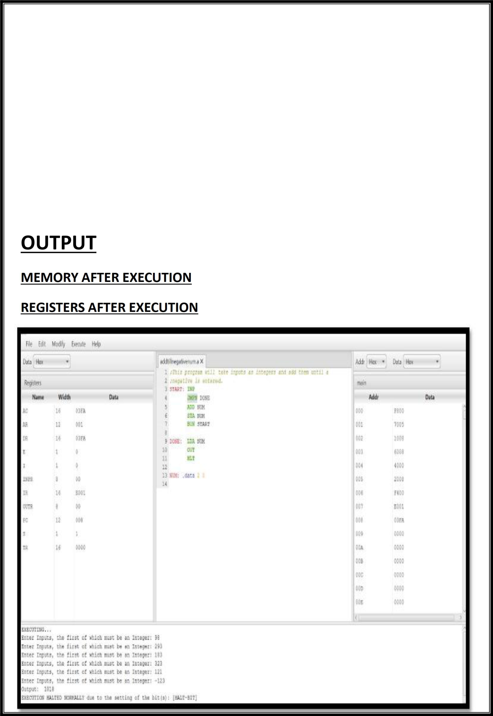**PRACTICAL 10**

**Objective**

**Write an assembly program that reads in integers and adds them together; until a negative non-zero number is read in. Then it outputs the sum (not including the last number).**

**PRACTICAL - 1 1**

**Objective**

**Write an assembly program that reads in integers and add them together ;until zero is read in Then output the sum.**

